

Tavneet singh (Enter your no. here)

Digital Image Processing lab Practicals (CSP 6113)

Submited to: Dr. Sakshi Arora Submitted by: Tavneet Singh Enrollment No. : (Enter your no. here)

Digital Image Processing Practical

Q1. How to read an image in python (using cv2 module, as numpy array and skimage module)

1. Using CV2 library

Following is the program to read images in python using **CV2 library**.

Program:

**import** cv2  
*# This import statement is used to import the python packages or # modules that required by our program.*  
*# Here we are importing cv2 module which is used for image reading # and also for displaying image in our program. # OpenCV reads the images as a numpy array.*   
  
img = cv2.imread(**"imagetr.jpg"**)  
*# cv2.imread() function is used to read and load image files stored # in your system.*  
  
cv2.imshow(**"input image"**, img)  
*# cv2.imshow() function is used to display the image in the # specified window.*  
  
print(type(img))  
*# the above print statement shows us the type of variable img is.*  
  
print(img.shape)  
*# This above print command prints to the terminal the image dimensions and also the number* *of color channels an image has.*  
  
print(img)  
*# As we know that the opencv reads the images as a numpy array so this print command displays*  
*# the numpy array values for each pixel in the image.*  
  
cv2.waitKey(0)  
*# cv2.waitKey() function waits for a couple of seconds as specified # by the user for a key event.*   
*# Here as we have defined zero here then the waitKey() function # waits infinitely for a key event to happen.*  
  
cv2.destroyAllWindows()  
*# This cv2.destroyAllWindows() function destroys all the opened GUI # windows which are opened by this particular program.*

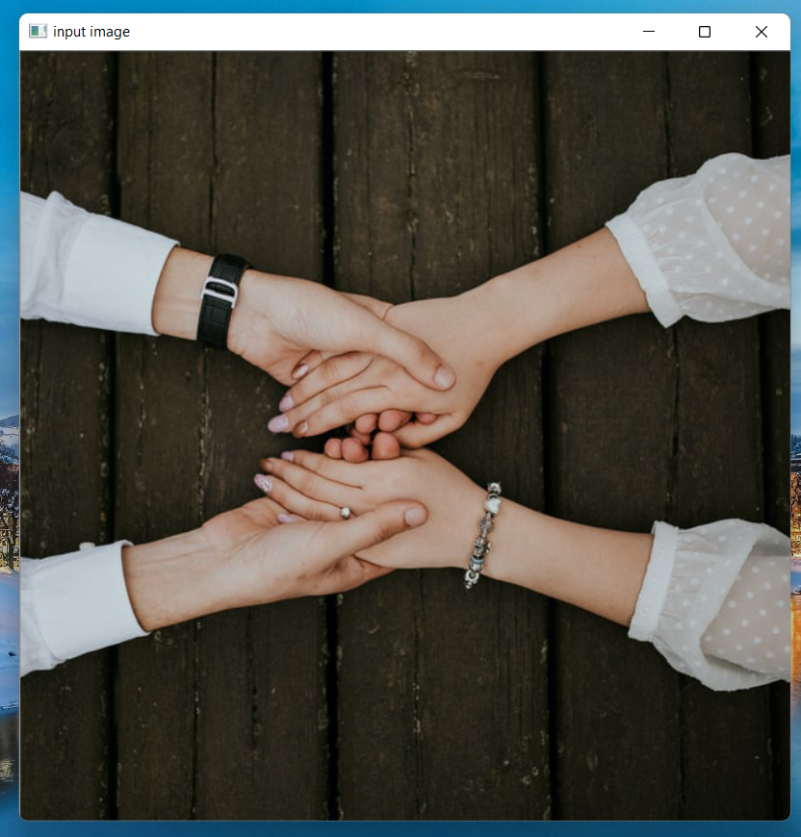Output (actual window size - Image has not been resized):

**Figure 1.1** Output of How to read an image in python (using OpenCV library)

Terminal Output:

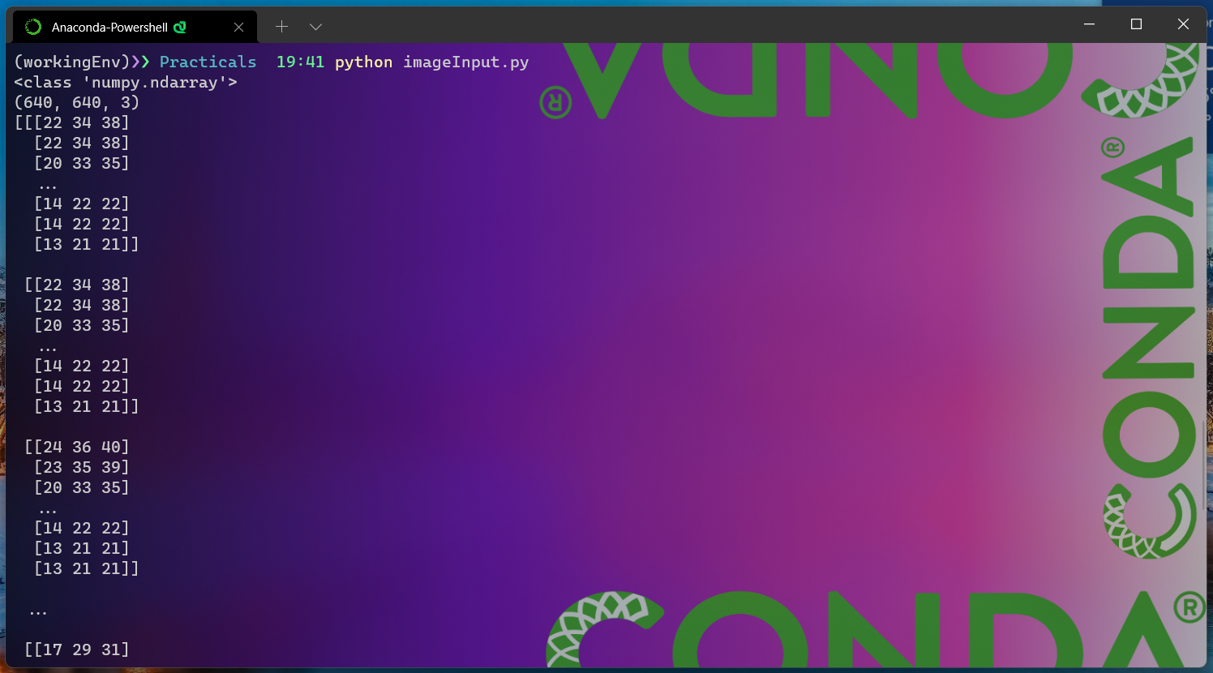

**Figure 1.1 (a)** Terminal output of How to read an image in python (using OpenCV library)

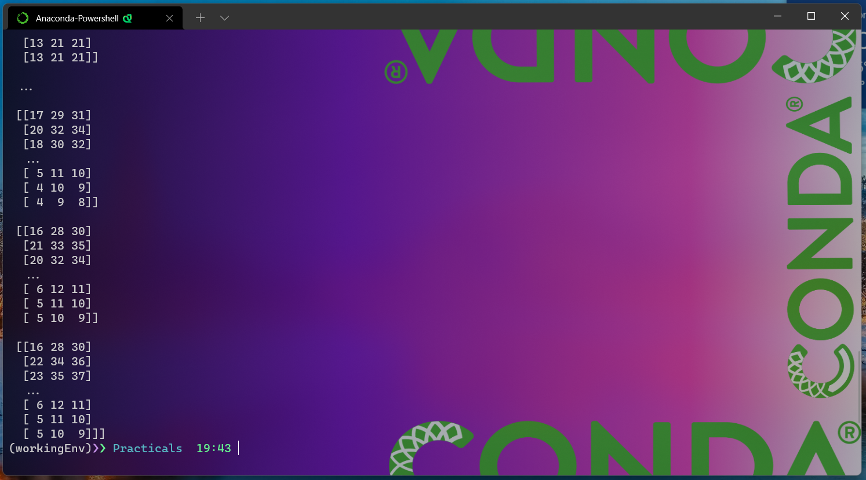

**Figure 1.1 (b)** Terminal output of How to read an image in python (using OpenCV library)

* Here as we can see in the above terminal screenshots the output of print(type(img))is <**class** ‘numpy.ndarray’> which shows us that our variable img is of type numpy array which means that the

cv2.imread()function reads the image as the numpy array.

* Also as we can see the output of print(img.shape) is (640,640,3) where the first 2 fields 640,640 represents the image dimensions and the third field which is 3 here represents that how man colour channel the image has. As the image that we read in the program “imgtetr.jpg” has three channels Red, Green and Blue so here in the output we have 3 in the third field.
* Also, as we know that cv2.imread()function also reads the image in the form of a numpy array. So, as we can see in the above terminal screenshots the output of print(img)is in the form of numpy array denoting the value of each pixel in the image.

Also, we can make use of command-line arguments to get the image source from the user that user wants to read. For that our program Looks like:

Program(Input from command-line argument):

**import** cv2  
*# This import statement is used to import the python packages or # modules that required by our program.*  
*# Here we are importing cv2 module which is used for image reading # and also for displaying image in our program. # OpenCV reads the images as a numpy array.*   
  
**import** argparse  
*# argparse is a command-line argument parsing library.*   
  
ap = argparse.ArgumentParser()  
ap.add_argument(**"-i"**, **"--image"**, required=**True**, help=**"path to input image file to be read"**)  
args = vars(ap.parse_args())  
  
img = cv2.imread(args[**"image"**])  
*# cv2.imread() function is used to read and load image files stored # in your system.*  
  
cv2.imshow(**"input image through command-line"**, img)  
*# cv2.imshow() function is used to display the image in the # specified window.*  
  
print(type(img))  
*# the above print statement shows us the type of variable img is.*  
  
print(img.shape)  
*# This above print command prints to the terminal the image dimensions and also the number*  
*# of color channels an image has.*  
  
print(img)  
*# As we know that the opencv reads the images as a numpy array so this print command displays*  
*# the numpy array values for each pixel in the image.*  
  
cv2.waitKey(0)  
*# cv2.waitKey() function waits for a couple of seconds as specified # by the user for a key event.*   
*# Here as we have defined zero here then the waitKey() function # waits infinitely for a key event to happen.*  
  
cv2.destroyAllWindows()  
*# This cv2.destroyAllWindows() function destroys all the opened GUI # windows which are opened by this particular program.*

Output:

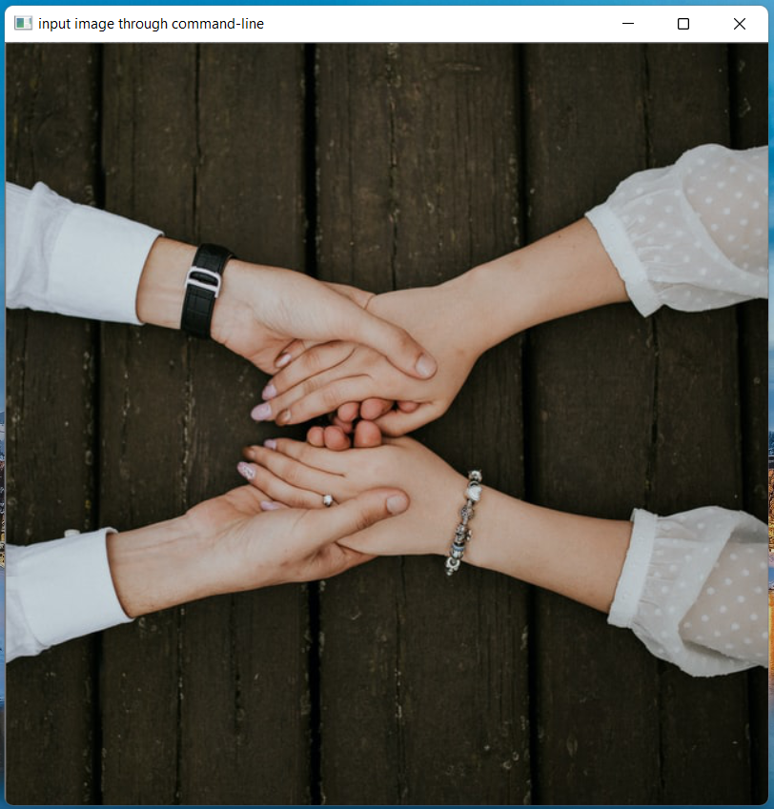

**Figure 1.2** Output of How to read an image in python (using OpenCV library) ( Input from Command-line arguments)

Terminal Output:

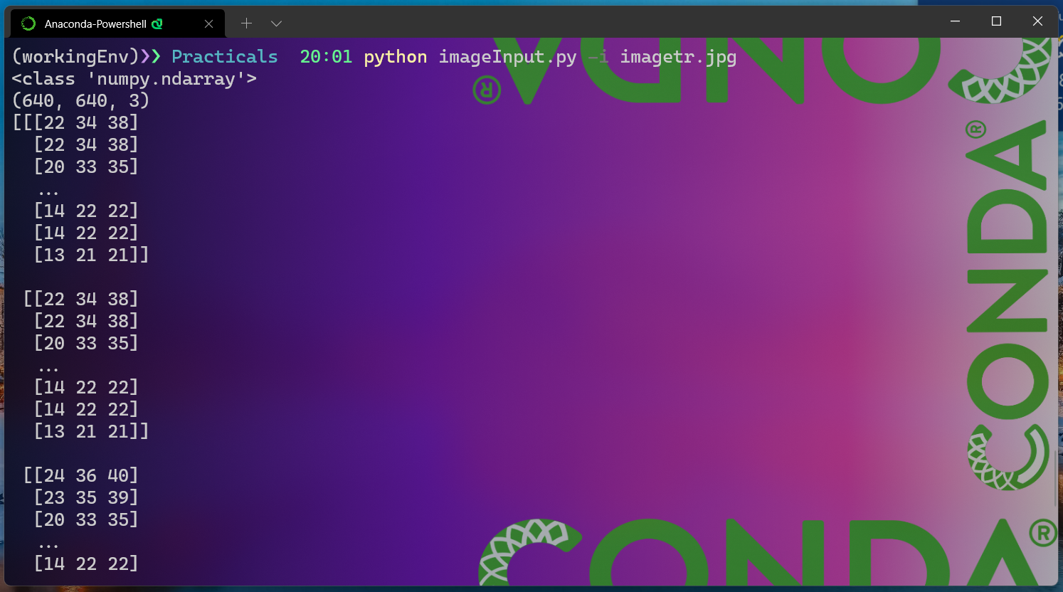

**Figure 1.2 (a)** Terminal output of How to read an image in python (using OpenCV library) ( Input from Command-line arguments)

( Input from Command-line arguments)

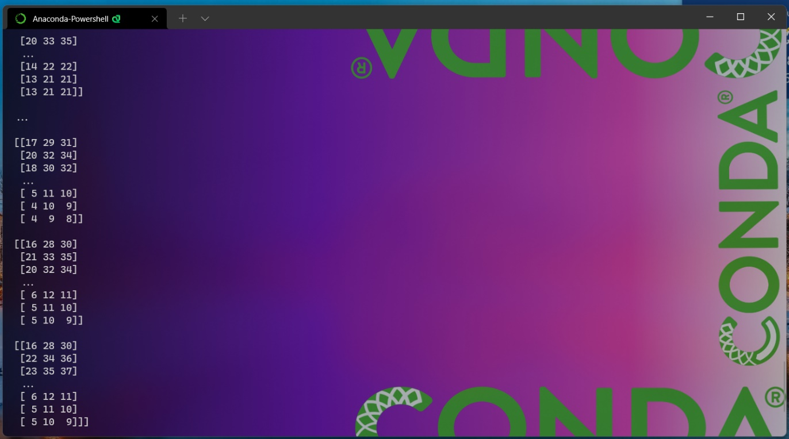

**Figure 1.2 (b)** Terminal output of How to read an image in python (using OpenCV library) ( Input from Command-line arguments)

( Input from Command-line arguments)

* As we can see in the above terminal screenshots that here we are providing the image file path to the program as a command-line argument rather than specifying within the program itself while running the program.

1. Using Skimage Library

Following is the program to read images in python using **Skimage library**.

Program:

**import** matplotlib.pyplot **as** plt  
**from** skimage **import** io  
*# This import statement is used to import the python packages or # modules that required by our program.*  
*# Here we are importing skimage module which is used for image # reading, image manipulation*  
*# and also for displaying image in our program.*  
*# Here also we are importing matplotlib.pyplot*  
*# skimage read the images a numpy arrays.*  
*# Here we are also importing matplotlib.pyplot which provides an # implicit, MATLAB-like, way of plotting.*  
*# It also used to opens figures on your screen, and also acts as the # figure GUI manager.*  
*# pyplot module is mainly intended for interactive plots and simple # cases of programmatic plot generation.*  
*# Here we are using matplotlib.pyplot to display title on our output # image.*  
  
img = io.imread(**"imagetr.jpg"**)  
*# io.imread() function of skimage isused to read images from a file # system / from a url.*  
  
print(type(img))  
*# The above print statement shows us the type of variable img is.*  
  
print(img.shape)  
*# This above print command prints to the terminal the image # dimensions and also the number of color channels an image has.*  
print(img)  
*# As we know that the skimage.io.imread() function reads the images as a numpy array so this print command displays*  
*# the numpy array values for each pixel in the image.*  
  
plt.title(**"Image Input Using Skimage library"**)  
*# Here plt.title() function is used to display title on the output # image plot.*  
  
io.imshow(img)  
*# io.imshow() is used to display the image*  
  
io.show()  
*# io.show() Launch the event loop of the current gui plugin, and # display all pending images, queued via imshow.*  
*# A call to show will block execution of code until all windows have # been closed.*  
*# this io.show() is required when we are using imshow in # non-interactive scripts.*

Output:

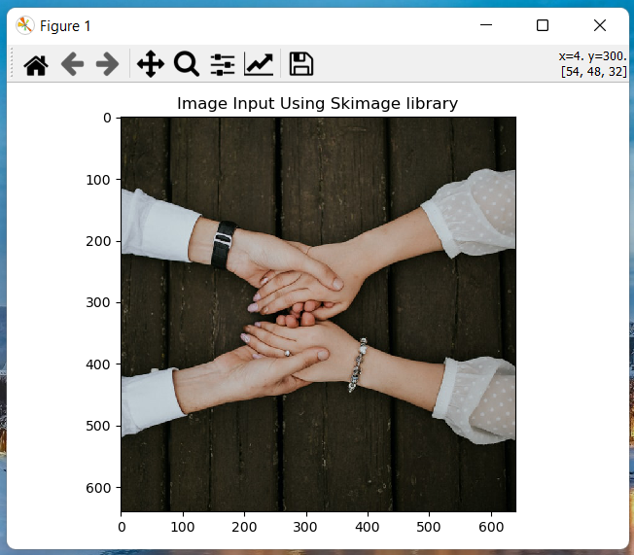

**Figure 1.3** Output of How to read an image in python (using Skinage library)

* So, as we can see from above output that here we have used **skimage library** to import and show the same image file which is “imagetr.jpg” as we have used in the previous program where we have used OpenCV library to import and show the image.

Terminal Output:

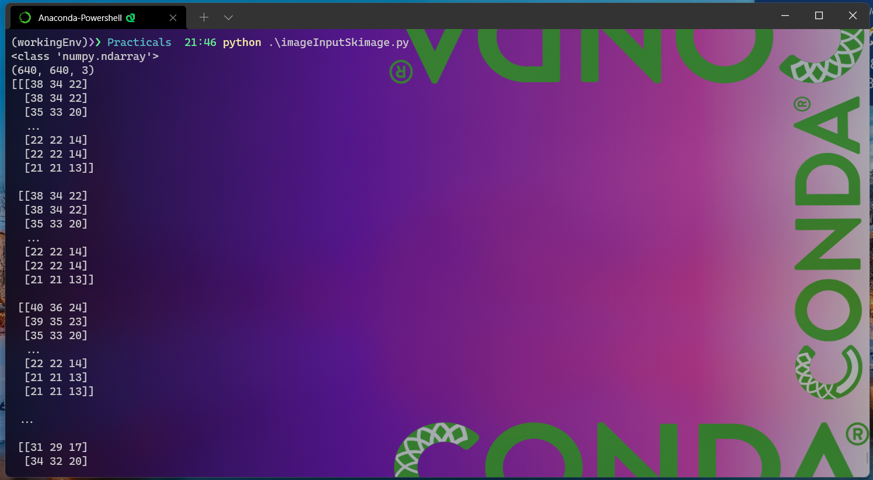

**Figure 1.3 (a)** Terminal output of How to read an image in python (using Skimage library)

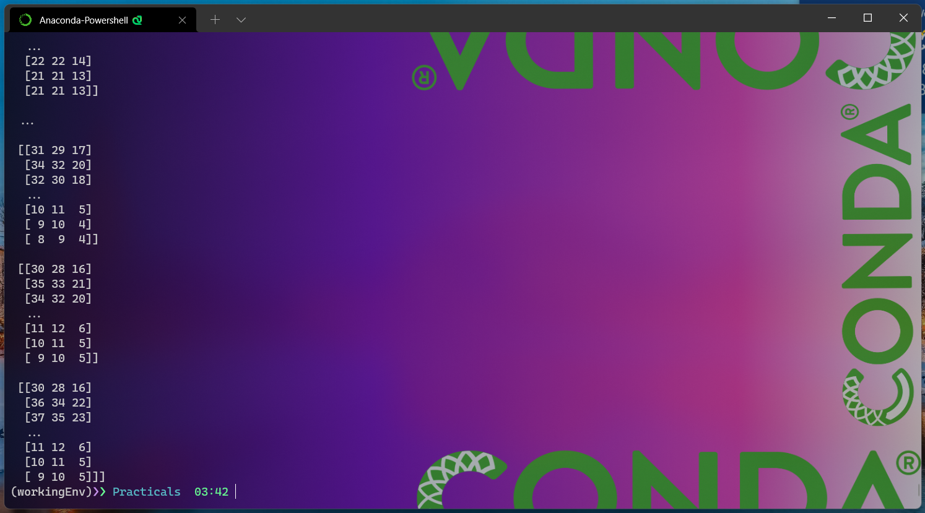

**Figure 1.3 (b)** Terminal output of How to read an image in python (using Skimage library)

* Here as we can see in the above terminal screenshots and compare the output of the both the above programs that the output of print(type(img))is <**class** ‘numpy.ndarray’> which shows us that our variable img is of type numpy array which means that the io.imread()function of skimage library reads the image as the numpy array same as cv2.imread()function.
* Also as we can see the output of print(img.shape) is (640,640,3) where the first 2 fields 640,640 represents the image dimensions and the third field which is 3 here represents that how man colour channel the image has. As the image that we read in the program “imgtetr.jpg” has three channels Red, Green and Blue so here in the output we have 3 in the third field. This output is same as previous program where we have imported image using cv2.imread()function.
* Also, as we see that io.imread()function reads the image in the form of a numpy array same as cv2.imread()function. So, as we can see in the above terminal screenshots the output of print(img)is in the form of numpy array denoting the value of each pixel in the image.

Q2. How to resize an image.

Following is the program to resize image in python using **CV2 module**.

Program:

**import** cv2  
*# This import statement is used to import the python packages or # modules that required by our program.*  
*# Here we are importing cv2 module which is used for image reading # and also for displaying image in our program.*  
*# opencv read the images a numpy arrays.*  
  
img = cv2.imread(**"imagetr.jpg"**)  
*# cv2.imread() function is used to read and load image files stored # in your system.*  
  
imgResize = cv2.resize(img, (320, 320))  
*# The above cv2.resize() function is used to resize the image src # down to or up to the specified size.*   
  
cv2.imshow(**"Orignal Image (640 x 640)"**, img)  
*# cv2.imshow() function is used to display the image in the # specified window.*  
*# This above program line is used to display the input image in its # orignal size.*  
  
cv2.imshow(**"Resized Image (320 x 320)"**, imgResize)  
*# This above program line is used to display the resized image.*  
  
cv2.waitKey(0)  
*# cv2.waitKey() function waits for a couple of seconds as specified # by the user for a key event.*  
*# Here as we have defined zero here then the waitKey() function # waits infinitely for a key event to happen.*  
  
cv2.destroyAllWindows()  
*# This cv2.destroyAllWindows() function destroys all the opened GUI # windows which are opened* *by this particular program.*

Output:

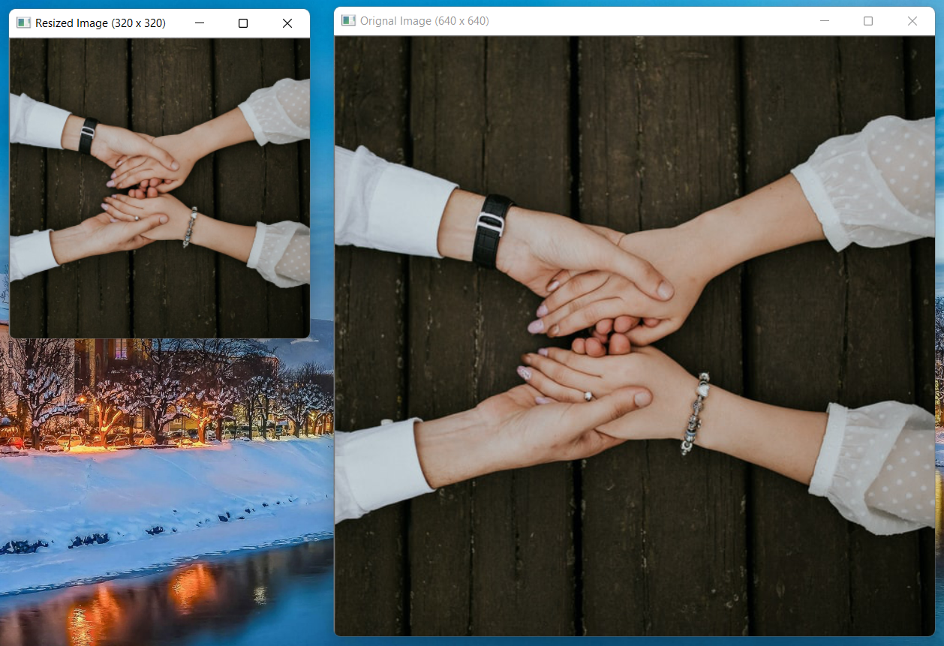

Figure2.1 Output of How to resize the image program. i) (Left) Resized Image (320 x 320) and ii) (Right) Original Image (640 x 640)

Figure 2.1(a) (i) Resized Image (320 x 320)

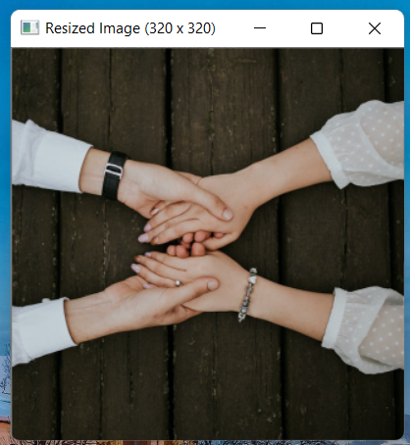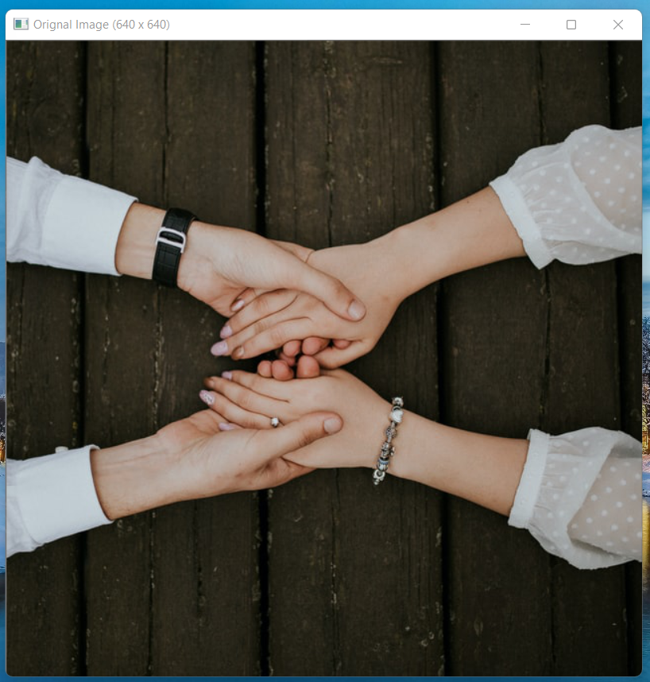

Figure 2.1 (b) (ii) Original Image (640 x 640)

* As we see in the above output screenshots that we have resized ii) Original image with the dimensions of 640 X 640 into i) Resized image with dimensions 320 X 320.

Q3. How to load multiple images in python.

Following is the program to load multiple images in python( done using **CV2 module**.)

Program:

**import** cv2  
**import** glob2  
*# This import statement is used to import the python packages or # modules that required by our program.*  
*# Here we are importing cv2 module which is used for image reading # and also for displaying image in our program.*  
*# opencv read the images a numpy arrays.*  
*# glob2 (short for global) module is used to return all file paths # that match a specific pattern. In general it is used to search # files and folders in the filesystem that match a certain pattern # as specified by user.*  
  
mainPath = **"inputimages/"**  
*# This is the base path where our images are located*  
  
ext = [**'png'**, **'jpg'**, **'jpeg'**, **'webp'**, **'tiff'**]  
*# this ext[] list specifies the type of image file extensions we # want to read.*  
  
constructedPath = []  
**for** e **in** ext:  
 constructedPath.extend(glob2.glob(mainPath + **'*.'** + e))  
*# the above for loop is used to get absolute path # (eg: inputimages\\image1.jpg) to each image file*  
*# stored in the base path folder based on type of extension that we # have specified in ext[] list and then add it to constructedPath[] # list fo next operation.*  
  
imgMulti = []  
**for** images **in** constructedPath:  
 img = cv2.imread(images)  
 imgMulti.append(img)  
*# this above for loop reads each image and the append its ndarray to # the imageMulti[] list*  
  
**for** i, imgSngl **in** enumerate(imgMulti):  
 cv2.imshow(**"Image Number {}"**.format(i), imgSngl)  
 print(type(imgSngl))  
 *# The above print statement shows us the type of variable*   
 *# imgSngl is.*  
   
 print(imgSngl.shape)  
 *# This above print command prints to the terminal the image # dimensions and also the number of color channels an image has.*  
  
*# This above for loop is used for Displaying the images that has # been read in the previous step.*  
  
print(imgMulti)  
*# This print statement is used to print the data contained in # imgMulti[] list which is ndarray data of images that we have read.*  
  
cv2.waitKey(0)  
*# cv2.waitKey() function waits for a couple of seconds as specified # by the user for a key event.*  
*# Here as we have defined zero here then the waitKey() function # waits infinitely for a key event to happen.*  
  
cv2.destroyAllWindows()  
*# This cv2.destroyAllWindows() function destroys all the opened GUI # windows which are opened by this particular program.*

Output:

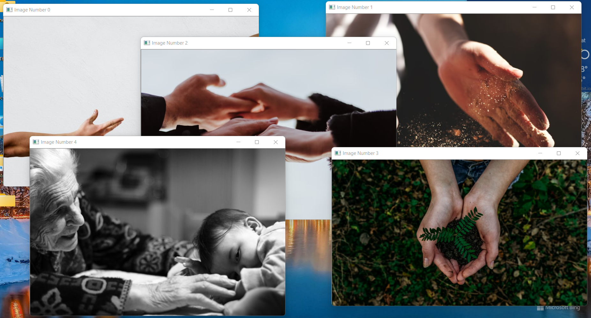

Figure 3.1 Output of How to load multiple images in python.

Terminal Output:

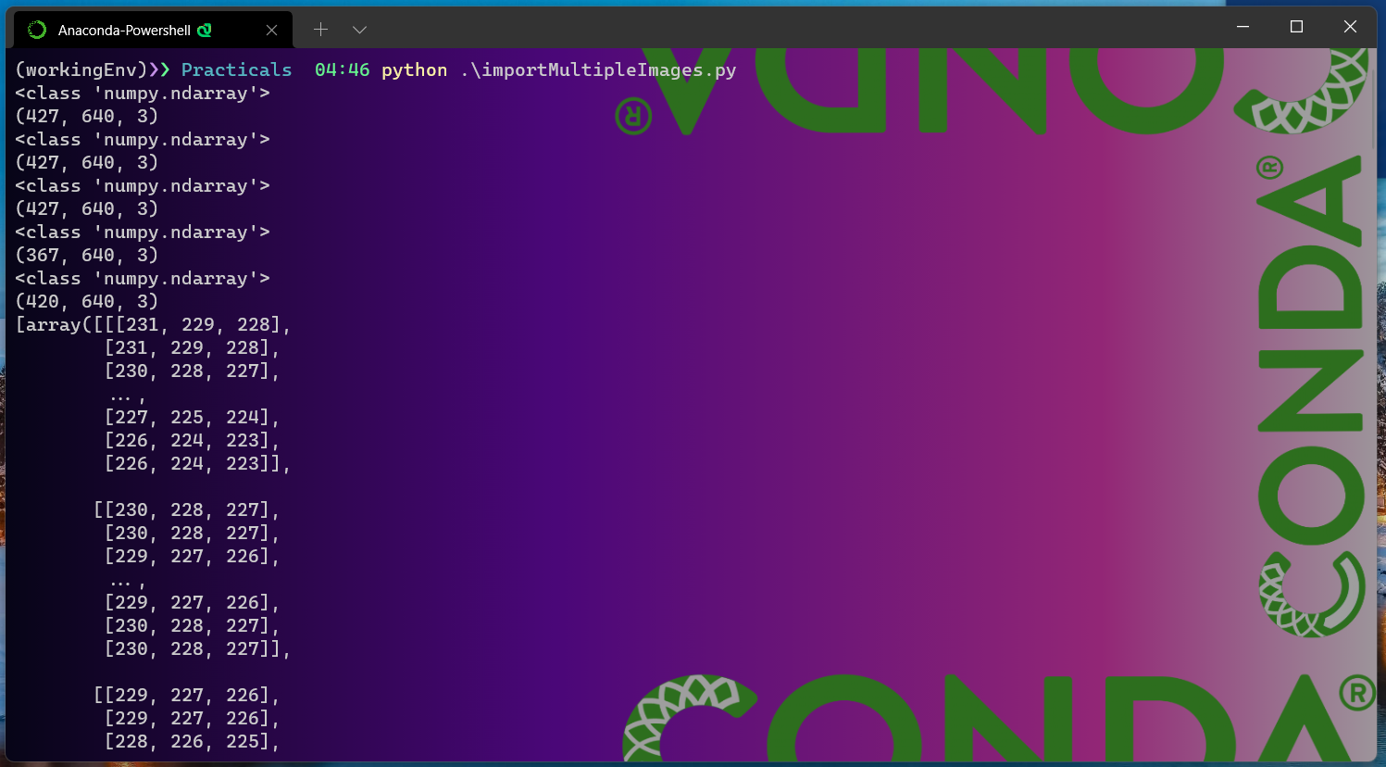

Figure 3.1 (a). Terminal Output of How to load multiple images in python.

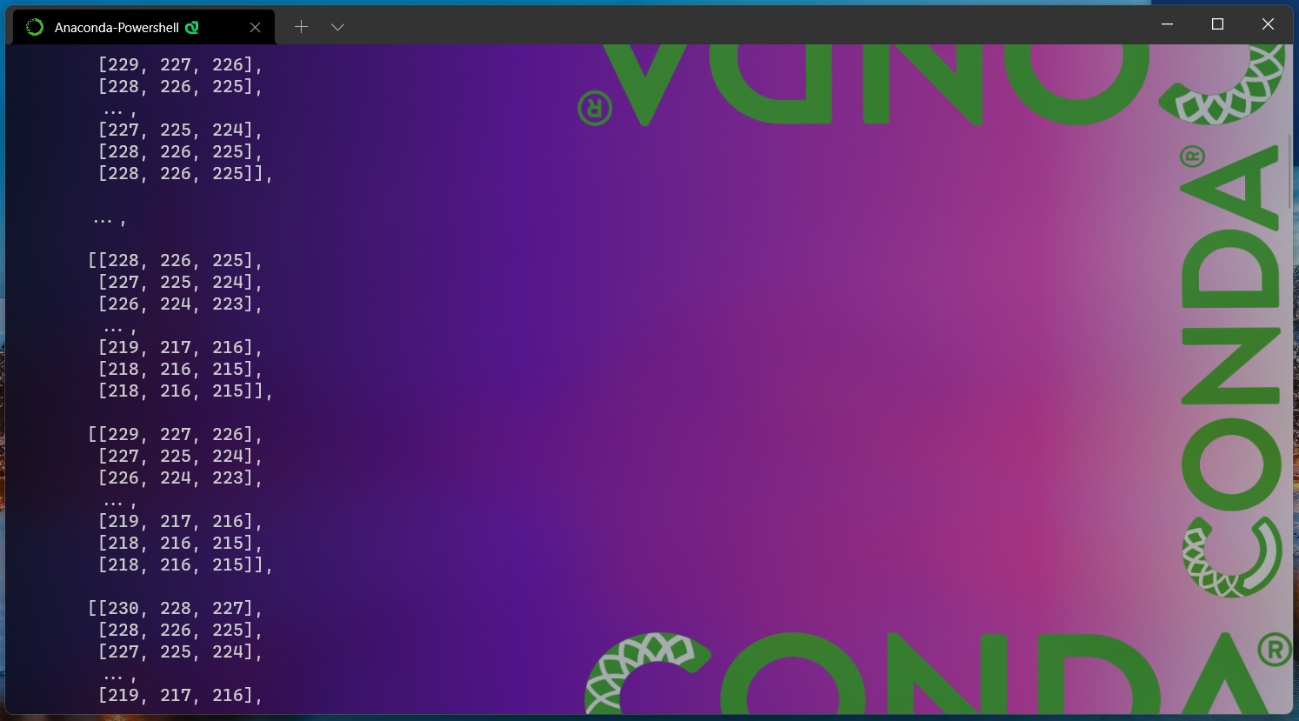

Figure 3.1 (b) Terminal Output of How to load multiple images in python.

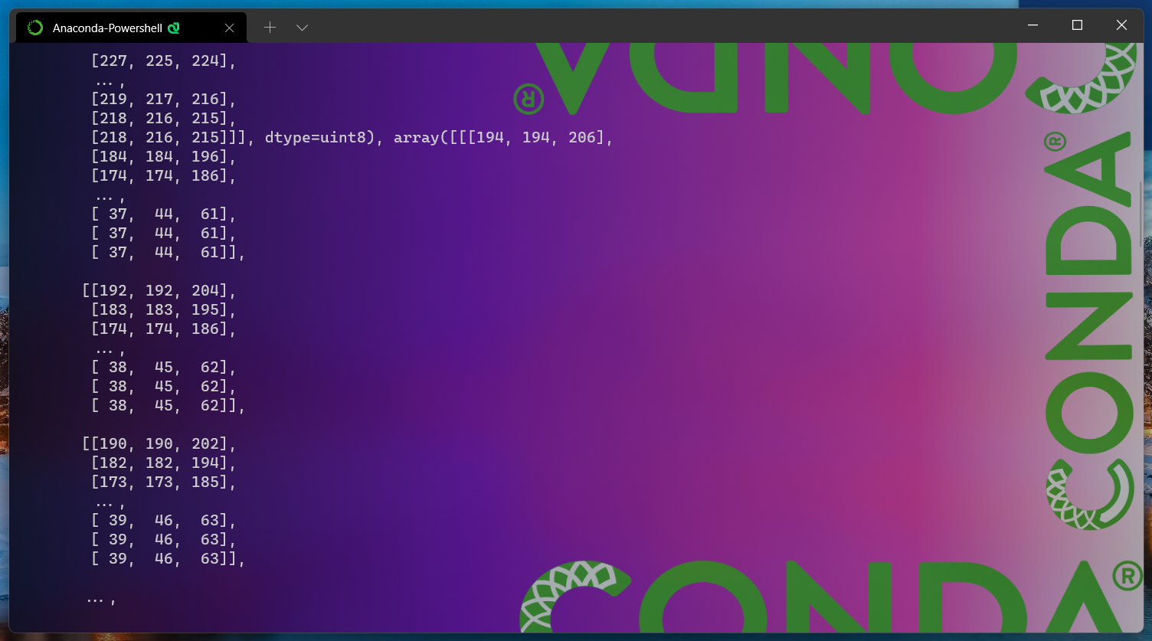

Figure 3.1 (c) Terminal Output of How to load multiple images in python.

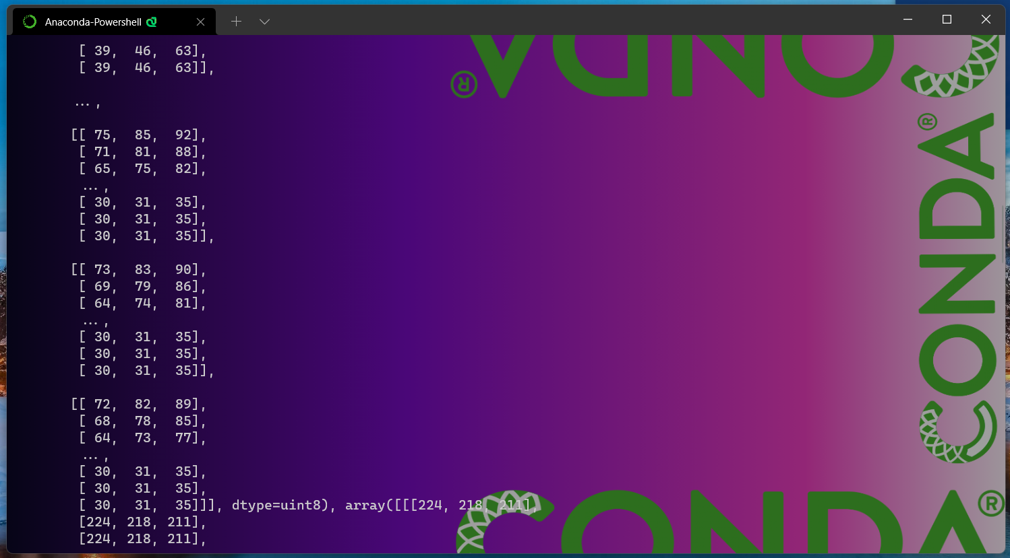

Figure 3.1 (d) Terminal Output of How to load multiple images in python.

* As we can see in the above Figure 3.1 we have 5 windows shown that displays the images that are read from the inputimages/ folder.

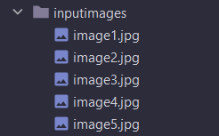

Figure 3.1 (e) inputimages/ folder.

* Here as we can see in figure 3.1 only 5 images are displayed as output on screen this is because our input images/ folder contains only 5 images.
* Also, as we can see in the Figure 3.1(a). 3.1(b), 3.1(c) and 3.2(d) the terminal output of our program that shows that each of images contained in the inputimages/ folder has been read in the form of numpy array(ndarray) and also shows the dimensions of each image as well as how many color channels each of our images read from inpytimages/ contain.

Q4. How to extract different color channels from an image.

Following is the program to extract different color channels from an image in python (done using **CV2 library)**.

Program:

**import** cv2  
**import** numpy **as** np  
*# This import statement is used to import the python packages or # modules that required by our program.*  
*# Here we are importing cv2 module which is used for image reading # and also for displaying image in our program.*  
*# opencv read the images a numpy arrays.*  
*# numpy is used to do manipulation on array object (which are Images # here).* *As our images are read in the form of numpy array.*  
  
img = cv2.imread(**"img.png"**)  
*# cv2.imread() function is used to read and load image files stored # in your system.*  
  
img = cv2.resize(img, (360, 360))  
*# cv2.resize() function resizes the input image into the provided # height and width.*  
  
cv2.imshow(**"orignal image"**, img)  
*# cv2.imshow() function is used to display the image in the # specified window.*  
  
imgr = cv2.cvtColor(img, cv2.COLOR_BGR2RGB)  
*# cv2.ctvColor() function converts the input image fron one color # space to* *another color space by provided the desired argument.*  
*# Here we are converting image from BGR color space to RGB color # space.*  
  
red, green, blue = cv2.split(imgr)  
*# cv2.split() function is used to split an image into its different # color channels.*  
*# This cv2.split() function splits the input image in BGR format # when we give it a* *image without converting its nd array to RGB # using CV2.COLOR_BGR2RGB function.*  
*# This is because the cv2.imread() function reads image as numpy # array in the BGR format.*  
  
zeros = np.zeros(imgr.shape[:2], dtype=**"uint8"**)  
*# np.zeros() function return a new array of given shape ( here shape # of our* *input image i.e; imgr) and type, filled with zeros.*  
  
cv2.imshow(**"Red channel of image"**, red)  
cv2.imshow(**"Green channel of image"**, green)  
cv2.imshow(**"Blue channel of image"**, blue)  
cv2.imshow(**"Visualized Red channel of image"**, cv2.merge([zeros, zeros, red]))  
cv2.imshow(**"Visualized Green channel of image"**, cv2.merge([zeros, green, zeros]))  
cv2.imshow(**"Visualized Blue channel of image"**, cv2.merge([blue, zeros, zeros]))  
*# cv2.merge() function is used to merge numpy arrays.*  
*# Here we are using cv2.merge() function to merge color channels of # image.*  
  
  
cv2.waitKey(0)  
*# cv2.waitKey() function waits for a couple of seconds as specified # by the user for a key event.*  
*# Here as we have defined zero here then the waitKey() function # waits infinitely for a key event to happen.*  
  
cv2.destroyAllWindows()  
*# This cv2.destroyAllWindows() function destroys all the opened GUI # windows which are opened*  
*# by this particular program.*

Output:

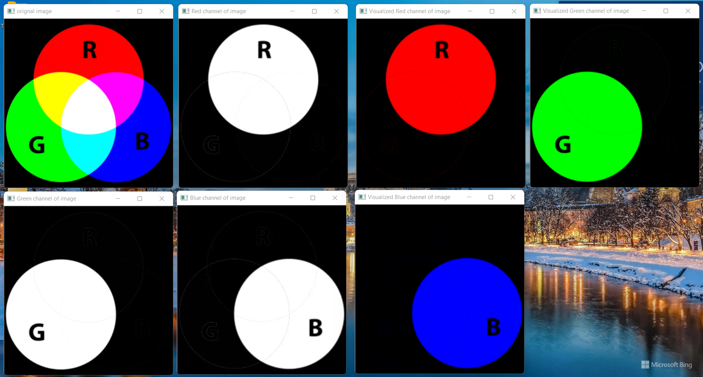

**Figure 4.1** Output of How to extract different color channels from an image. **1:** Original Image, **2:** Red channel of image, **3:** Green Channel of image **4:** Blue Channel of the image, **5:** Visualized Red Channel of image, **6:** Visualized Green Channel of image and **7:** Visualized Blue Channel of image

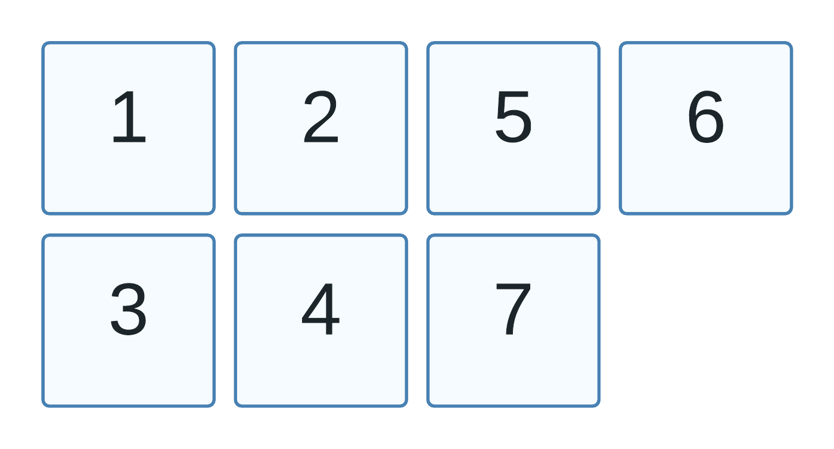

d

* As we see in the above Figure 4.1 we have extracted the Red, Green, Blue channels from our input image which contains all the 3 channels in it.
* As you can see in above figure that after extracting the red, green and blue channels from the image we have showcase each channel in different formats. In one format we have shown the separated channel in its actual color **(Figure 4.1 (5, 6 and 7))** and other where the specified color channel is just highlighted or we can say in greyscale form **(Figure 4.1 (2, 3 and 4)).** We can also stitch these output windows together as they are just a numpy array objects.
* For doing this extraction we make use of 2 opencv functions.
  + The first one is**: cv2.cvtColor(img, cv2.COLOR_BGR2RGB)**. This function converts the image from BGR to RGB color space because here we have provided **cv2.COLOR_BGR2RGB** as the argument to the function. We do this conversion because the **cv2.imread()** function that we use to read the images reads the images in BGR format. The use of this function is not necessarily required, we can also make our program work without the use of this function as well. The only reason we use this function here in our program is for our convenience.
  + And the second function is **cv2.split().** This function is used to split the image into its different channels. Here this function splits the input image (which is in the form of numpy array) into different channels with **order as red, green, and blue channels**. If we have not converted the image from BGR to RGB color space then this function splits the image into its different channels with the **order of blue, green, and red channels.**
* After this **cv2.split()** we display the separated channels using cv2.imshow() function for each of the separated channel.

Now let us take another picture and extract different color channels from it as well. For doing this the whole program remains same but only the input image changes.

Output: ( with different image as input )

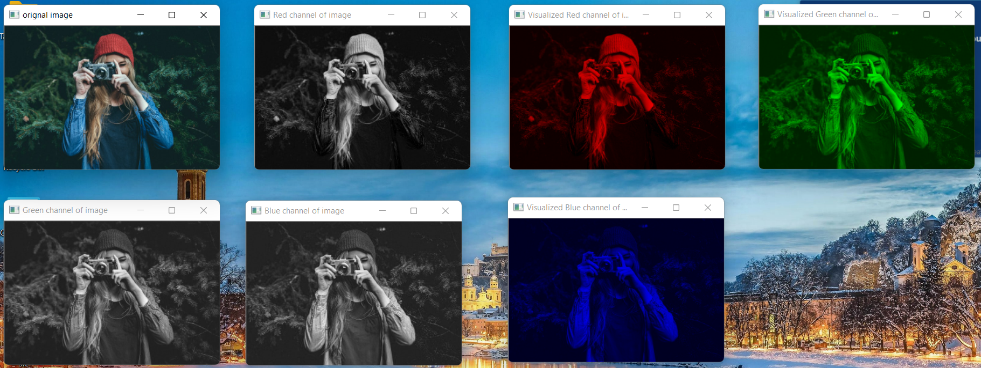

**Figure 4.1 (a)** Output of How to extract different color channels from an image (with a different image as input). **1:** Original Image, **2:** Red channel of image, **3:** Green Channel of image **4:** Blue Channel of the image, **5:** Visualized Red Channel of image, **6:** Visualized Green Channel of image and **7:** Visualized Blue Channel of image



Q5. How to convert an image from rgb to gray.

Following is the program to convert an image from RGB to Grayscale in python( done using Opencv library)

Program:

**import** cv2  
*# This import statement is used to import the python packages or # modules that required by our program.*  
*# Here we are importing cv2 module which is used for image reading # and also for displaying image in our program.*  
*# opencv read the images a numpy arrays.*  
  
img = cv2.imread(**"imagergb1.jpg"**)  
*# cv2.imread() function is used to read and load image files stored # in your system.*  
  
img = cv2.resize(img, (320, 214))  
*# cv2.resize() function resizes the input image into the provided # height and width.*  
  
imgr = cv2.cvtColor(img, cv2.COLOR_BGR2GRAY)  
*# cv2.ctvColor() function converts the input image fron one color # space to* *another color space by provided the desired argument.*  
*# Here we are converting image from BGR color space to a greyscale # image*  
  
cv2.imshow(**"orignal image"**, img)  
cv2.imshow(**"Greyscale image of input image"**, imgr)  
*# cv2.imshow() function is used to display the image in the # specified window.*  
  
cv2.waitKey(0)  
*# cv2.waitKey() function waits for a couple of seconds as specified # by the user for a key event.*  
*# Here as we have defined zero here then the waitKey() function # waits infinitely for a key event to happen.*  
  
cv2.destroyAllWindows()  
*# This cv2.destroyAllWindows() function destroys all the opened GUI # windows which are opened* *by this particular program.*

Output:

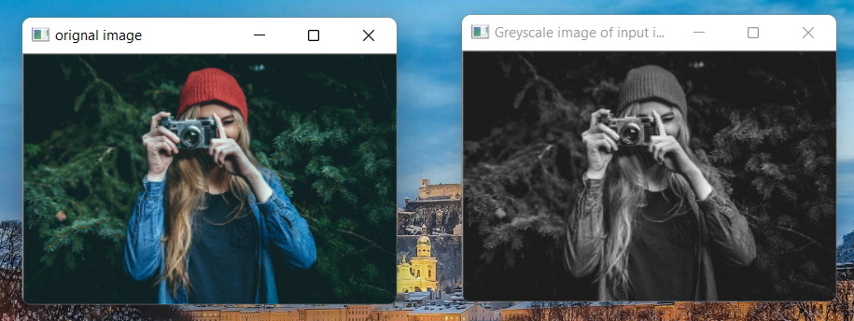

**Figure 5.1** Output of How to convert image from RGB to Greyscale. (Left): Original Image, and (Right): Greyscale image of the input image

* As we can see in above Figure 5.1 on left we have original image which is an RGB image and on right we have the greyscale image that we have converted from the original image.
* To convert our image from RGB to greyscale we have used the **cv2.cvtColor(img, cv2.COLOR_BGR2GRAY)**function provided the argument that tells the **cv2.cvtColor()**function to convert the image from which color space to which . As here we have passed cv2.COLOR_BGR2GRAY to the **cv2.cvtColor()** function. So, It converts our image from RGB color space to greyscale image.

Q6. How to convert an image from greyscale to binary image.

Following is the program to convert an image from Grayscale to binary in python( done using Opencv library)

Program:

**import** cv2  
*# This import statement is used to import the python packages or # modules that required by our program.*  
*# Here we are importing cv2 module which is used for image reading # and also for displaying image in our program.*  
*# opencv read the images a numpy arrays.*  
*# As our images are read in the form of numpy array.*  
  
img = cv2.imread(**"imagergb1.jpg"**)  
*# cv2.imread() function is used to read and load image files stored # in your system.*  
  
img = cv2.resize(img, (320, 214))  
*# cv2.resize() function resizes the input image into the provided height and width.*  
  
imgGrey = cv2.cvtColor(img, cv2.COLOR_BGR2GRAY)  
*# cv2.ctvColor() function converts the input image from one color # space to another color space by provided the desired argument.*  
*# Here we are converting image from BGR color space to a greyscale image.*  
  
(thresh, imgBinary) = cv2.threshold(imgGrey, 127, 255, cv2.THRESH_BINARY)  
*# cv2.threshhold() function applies fixed-level thresholding to a*  
*# multiple-channel array (which is our greyscale image (imgGrey) # here.*  
*# This function is typically used to get a bi-level (binary) image*  
*# out of a grayscale image or for removing a noise, that is,*  
*# filtering out pixels with too small or too large values.*  
*# There are several types of thresholding supported by the function.*  
*# They are determined by type parameter.*  
  
cv2.imshow(**"orignal image"**, img)  
cv2.imshow(**"Greyscale image of input image"**, imgGrey)  
cv2.imshow(**"Binary image of input image"**, imgBinary)  
*# cv2.imshow() function is used to display the image in the # specified window.*  
  
cv2.waitKey(0)  
*# cv2.waitKey() function waits for a couple of seconds as specified # by the user for a key event.*  
*# Here as we have defined zero here then the waitKey() function # waits infinitely for a key event to happen.*  
  
cv2.destroyAllWindows()  
*# This cv2.destroyAllWindows() function destroys all the opened GUI # windows which are opened* *by this particular program.*

Output:

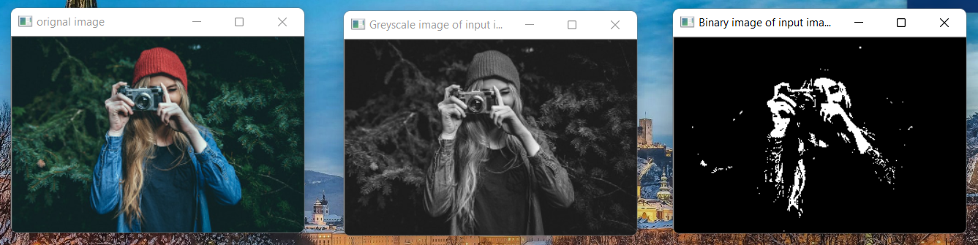

**Figure 6.1** Output of How to convert image from RGB to Binary. (Left): Original Image, (Middle): Greyscale image of the input image, and (Right): Binary image of the input image

* As we can see in above Figure 6.1 on left we have original image which is an RGB image, in the middle we have the greyscale image that we have converted from the original image, and on the right we have Binary image which is converted from Greyscale image of our input image.
* To convert our image from RGB to Binary we have to first convert our image to Greyscale image. For doing that we have used the **cv2.cvtColor(img, cv2.COLOR_BGR2GRAY)**function provided the argument that tells the **cv2.cvtColor()**function to convert the image from which color space to which . As here we have passed **cv2.COLOR_BGR2GRAY** to the **cv2.cvtColor()** function. So, It converts our image from RGB color space to greyscale image.
* when our input image gets been converted into greyscale image, after that we use this Greycale image and convert it into Binary image. For doing that we have used **(thresh, imgBinary) = cv2.threshold(imgGrey, 127, 255, cv2.THRESH_BINARY)**function which is a thresholding function. This function applies fixed-level thresholding of to a multiple-channel array (which is our greyscale image (imgGrey) here. Here this function is used to convert our greyscale image(imgGrey) into binary image by applying thresholding over our greyscale image that we have passed into this function as argument.
* Our **cv2.threshold()** function is capable of doing many types of thresholding so, how can we specify which type of thresholding we require. For that here we are passing **cv2.THRESH_BINARY** as one of the function argument that tells our **cv2.threshold()** function to do Binary thresholding.
* This function returns us a touple in which one value is the threshold value and the other is the binary image numpy array.

Q7. How to upsample an image.

**Upsampling / upscaling** is the process of increasing the resolution of an image. Which means in upsampling we are increasing the dimensions of the image by introducing more information (or we can say pixels data) into the image.

Following is the program for upsampling an image.

Program:

**import** cv2  
*# This import statement is used to import the python packages or # modules that required by our program.*  
*# Here we are importing cv2 module which is used for image reading # and also for displaying image in our program.*  
*# opencv read the images a numpy arrays.*  
  
img = cv2.imread(**"imagetr.jpg"**)  
*# cv2.imread() function is used to read and load image files stored # in your system.*  
  
scalingPercentage = 115  
*# This above scaligPercentage variable has the percentage value*  
*# by which the image has to be resized.*  
  
newWidth = int(img.shape[1] * scalingPercentage / 100)  
newHeight = int(img.shape[0] * scalingPercentage / 100)  
*# These above two statements calculate the new height and*  
*# width of the new resized image. which depends on the*  
*# scaling factor that we are using.*  
  
dim = (newWidth, newHeight)  
*# This is the new dimensions of the upscaled image*  
  
imgUpscaled = cv2.resize(img, dim, interpolation=cv2.INTER_CUBIC)  
*# The above cv2.resize() function is used to resize the image src # down to or up to the specified size.*  
  
print(**"Original image dimensions: "**, img.shape)  
*# This above image prints the image dimensions of actual image.*  
  
print(**"New Resized image dimensions: "**, imgUpscaled.shape)  
*# This above print statement prints the upscaled image dimensions.*  
  
cv2.imshow(**"Orignal Image (640 x 640)"**, img)  
cv2.imshow(**"Upsampled/Upscaled image"**, imgUpscaled)  
  
cv2.waitKey(0)  
*# cv2.waitKey() function waits for a couple of seconds as specified # by the user for a key event.*  
*# Here as we have defined zero here then the waitKey() function # waits infinitely for a key event to happen.*  
  
cv2.destroyAllWindows()  
*# This cv2.destroyAllWindows() function destroys all the opened GUI # windows which are opened* *by this particular program.*

Output:

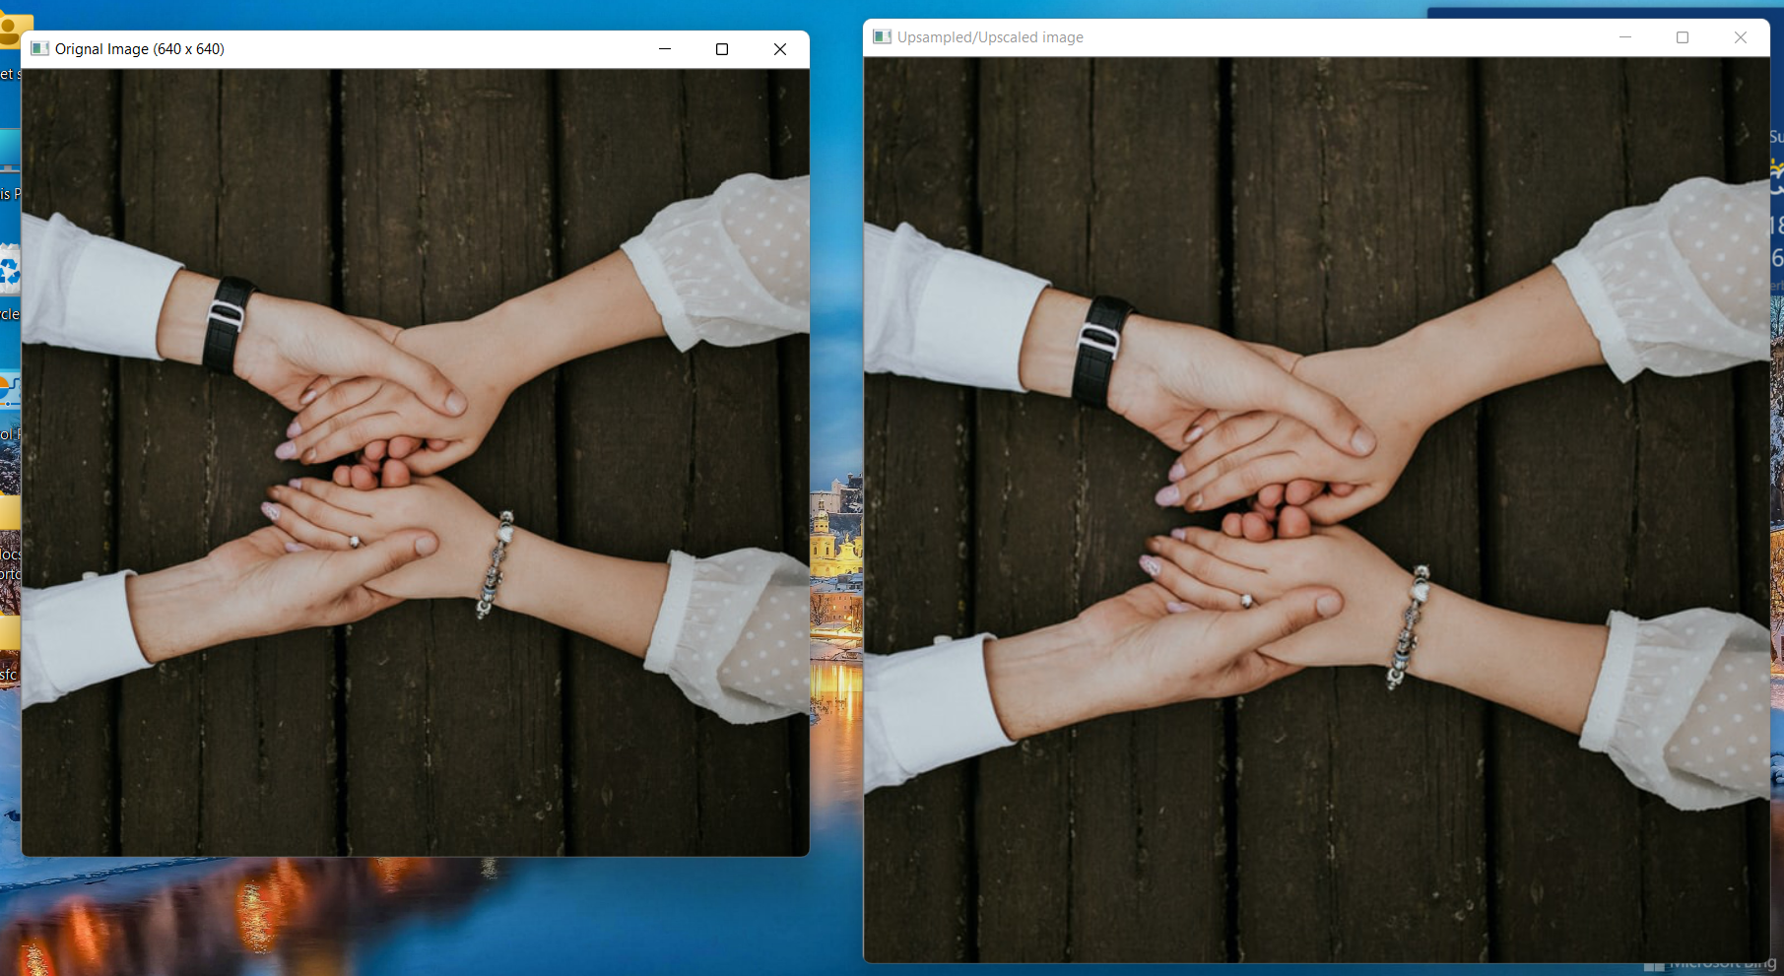

**Figure 7.1** Output of How to Upsample an image. (Left): Original Image, and (Right): upsampled/Upscaled image

Terminal Output:

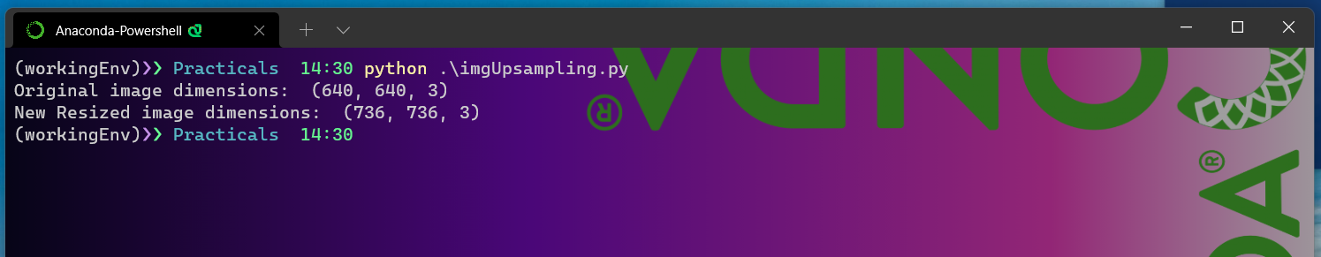

**Figure 7.1 (a)** Terminal Output of How to Upsample an image.

* As we can see in Figure 7.1 on the left side we have original image having dimensions of 640 x 640 and on the right side we have upscaled/upsampled image of the original image having scaling percentage of 115.
* For doing this upsampling/ upscaling we have used **cv2.resize()** method. Here we have chosen scaling percentage of 115% for upscaling our image. We can choose any scaling factor above 100% and that results in upscaled image. This is because the scaling percentage of 100% is the scaling percentage of the original image. So, anything above that 100% scaling percentage will result in an upscaled image.
* We have used this scaling percentage to calculate new image height and width . This is very important to calculate the appropriate dimensions of the image that we want based on scaling factor. This calculation will help us to ensure that the aspect ratio of the image is preserved even after upscaling.
* As we know that for doing upsampling/upscaling of our images we have to make use of Interpolation. There are various interpolation methods/techniques available to us in OpenCV library Here we have used **cv2.INTER_CUBIC** interpolation technique for upscaling of our image. This interpolation technique gives us best quality upscaled image, but the only drawback of this technique is that it is little bit slow(in terms of milliseconds) in its operation as compared to other interpolation techniques.
* For upscaling we pass image src, calculated dimensions of the new image that we want and also interpolation technique chosen to the **cv2.resize(img, dim, interpolation=cv2.INTER_CUBIC)** function that returns the upscaled image that we see on the left side in the Figure7.1 .
* Also, as we can see in Figure7.1 (a) (Terminal output) that the dimensions of original as well as upscaled image that are printed on to terminal screen are different. The original image has dimensions as 640 x 640 with 3 channels(RGB) and the upscaled image has dimension of 736 x 736 with 3 channels(RGB).
* As we can observe the dimensions of the original as well as upscaled image we can conclude that the dimensions of upscaled image are greater than the dimensions of original image. So, we can say that our original image has been upscaled.

Q8. How to downsample an image.

Downsampling/Downscaling **is** the process of decreasing the resolution of an image. Which means in downscaling we are decreasing the dimensions of the image image by reducing the information (or we can say by reducing the pixels data) from the image.

Program:

**import** cv2  
*# This import statement is used to import the python packages or # modules that required by our program.*  
*# Here we are importing cv2 module which is used for image reading # and also for displaying image in our program.*  
*# opencv read the images a numpy arrays.*  
  
img = cv2.imread(**"imagetr.jpg"**)  
*# cv2.imread() function is used to read and load image files stored # in your system.*  
  
scalingPercentage = 50  
*# This above scaligPercentage variable has the percentage value*  
*# by which the image has to be resized.*  
  
newWidth = int(img.shape[1] * scalingPercentage / 100)  
newHeight = int(img.shape[0] * scalingPercentage / 100)  
*# These above two statements calculate the new height and*  
*# width of the new resized image. which depends on the*  
*# scaling factor that we are using.*  
  
dim = (newWidth, newHeight)  
*# This is the new dimensions of the downscaled image*  
  
imgDownscaled = cv2.resize(img, dim, interpolation=cv2.INTER_AREA)  
*# The above cv2.resize() function is used to resize the image src # down to or up to the specified size.*  
  
print(**"Original image dimensions: "**, img.shape)  
*# This above image prints the image dimensions of actual image.*  
  
print(**"New Resized image dimensions: "**, imgDownscaled.shape)  
*# This above print statement prints the downscaled image dimensions.*  
  
cv2.imshow(**"Orignal Image (640 x 640)"**, img)  
cv2.imshow(**"Downsampled/Downscaled image"**, imgDownscaled)  
  
cv2.waitKey(0)  
*# cv2.waitKey() function waits for a couple of seconds as specified # by the user for a key event.*  
*# Here as we have defined zero here then the waitKey() function # waits infinitely for a key event to happen.*  
cv2.destroyAllWindows()  
*# This cv2.destroyAllWindows() function destroys all the opened GUI # windows which are opened* *by this particular program.*

Output: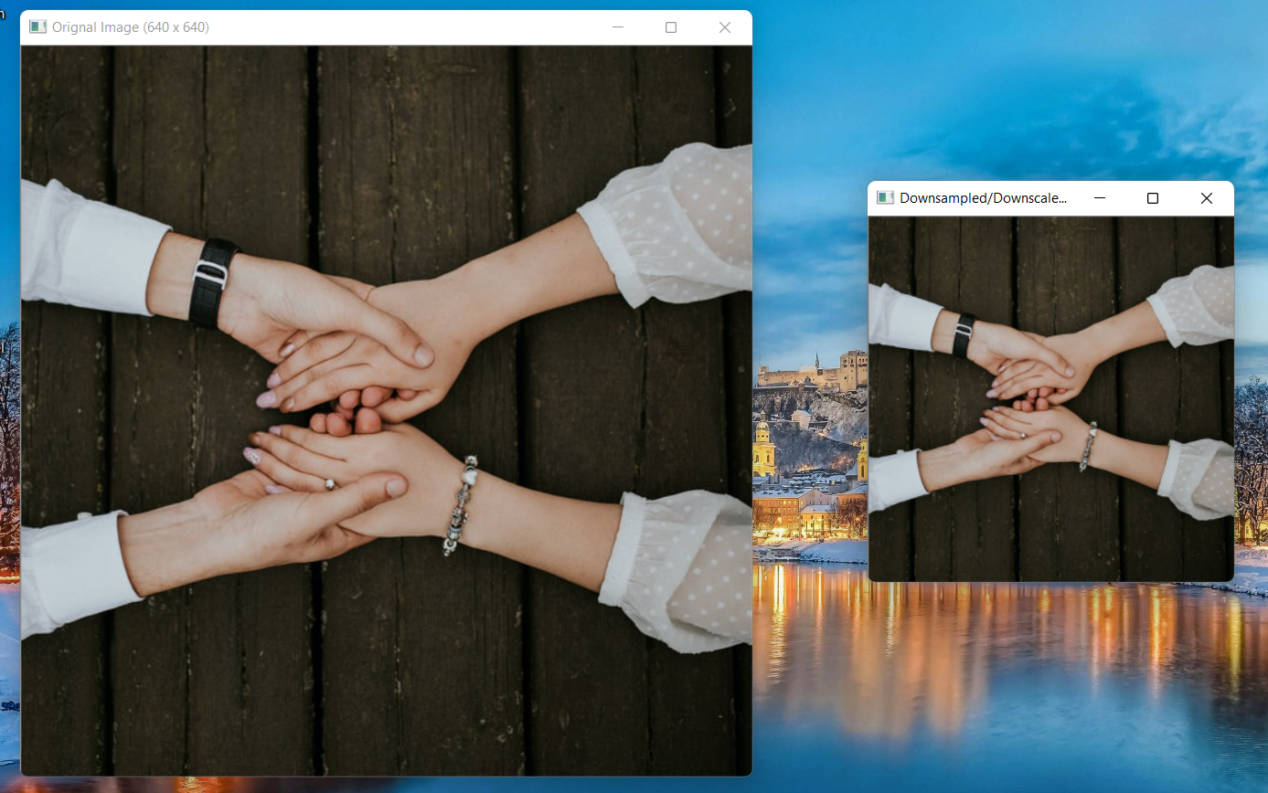

**Figure 8.1** Output of How to Down sample an image. (Left): Original Image, and (Right): Downsampled/Downscaled image

Terminal Output:

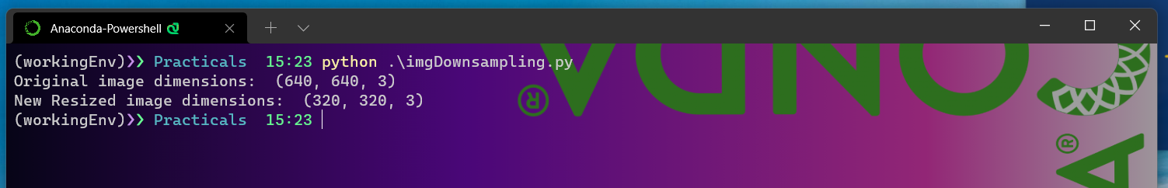

**Figure 8.1 (a)** Terminal Output of How to Down sample an image.

* As we can see in Figure 8.1 on the left side we have original image having dimensions of 640 x 640 and on the right side we have downsample/downscaled image of the original image having scaling percentage of 50.
* For doing this Downscaling we have used **cv2.resize()** method. Here we have chosen scaling percentage of 50%for downscaling our image. We can choose any scaling factor below 100% and that results in downscaled image. This is because the scaling percentage of 100% is the scaling percentage of the original image. So, anything below that 100% scaling percentage will result in an downscaled image.
* We have used this scaling percentage to calculate new image height and width . This is very important to calculate the appropriate dimensions of the image that we want based on scaling factor. This calculation will help us to ensure that the aspect ratio of the image is preserved even after downscaling.
* As we know that for doing downsampling/downscaling of our images we have to make use of Interpolation. There are various interpolation methods/techniques available to us in OpenCV library Here we have used **cv2.INTER_AREA** interpolation technique for upscaling of our image. This interpolation technique gives us best quality downscaled image.
* For downscaling of our image we pass src of the image that we want to down scale , calculated dimensions of the new image that we want and also interpolation technique chosen to the **cv2.resize(img, dim, interpolation=cv2.INTER_AREA)** function that returns the downscaled image that we see on the left side in the Figure8.1 .
* Also, as we can see in Figure8.1 (a) (Terminal output) that the dimensions of original as well as downscaled image that are printed on to terminal screen are different. The original image has dimensions as 640 x 640 with 3 channels(RGB) and the downscaled image has dimension of 320 x 320 with 3 channels(RGB).
* As we can observe the dimensions of the original as well as upscaled image we can conclude that the dimensions of downscaled image are less than the dimensions of original image. So, we can say that our original image has been downscaled.

Q9. Write the program to generate the negative of image.

Following is the program to generate negative of image

Program:

**import** cv2  
*# This import statement is used to import the python packages or # modules that required by our program.*  
*# Here we are importing cv2 module which is used for image reading # and also for displaying image in our program.*  
*# opencv read the images a numpy arrays.*  
  
img = cv2.imread(**"imagetr.jpg"**)  
*# cv2.imread() function is used to read and load image files stored # in your system.*  
  
imgNegative = cv2.bitwise_not(img)  
*# cv2.bitwise_not() is used to invert every bit present in the image # array.*  
  
cv2.imshow(**"Orignal Image"**, img)  
cv2.imshow(**"Ngative image"**, imgNegative)  
  
cv2.waitKey(0)  
*# cv2.waitKey() function waits for a couple of seconds as specified # by the user for a key event.*  
*# Here as we have defined zero here then the waitKey() function # waits infinitely for a key event to happen.*  
  
cv2.destroyAllWindows()  
*# This cv2.destroyAllWindows() function destroys all the opened GUI # windows which are opened* *by this particular program.*

Output:

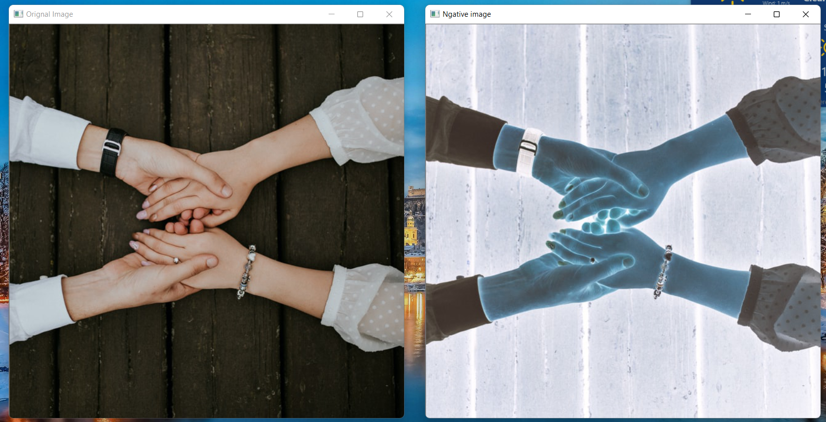

**Figure 9.1** Output of Write the program to generate the negative of image (Left): Original Image, and (Right): Negative image

* As we can see in the Figure 11.1 on the left side we have the rignal image and on the right side we have the negative image(That we have extraxted from our original image)
* For generating the negative of our original image we have used **cv2.bitwise_not(img)** function in our program. This **cv2.bitwise_not(img)** function inverts every pixel value present in image numpy array. The result of this **cv2.bitwise_not(img)** function is an image array in which every pixel value is inverted. And that image having pixel values inverted is our required negative image.

Q10. Write a program to increase the contrast of the image using contrast Stretching.

Contrast stretching is a technique that attempts to improve an image by stretching the range of intensity values it contains to make full use of possible values. contrast stretching is restricted to a linear mapping of input to output values. Contrast stretching is applied directly on the image by modifying each pixel present in the image by applying point operations on the image rather than using a kernel for determining the value of each pixel by using the values of neighbourhood pixels. Contrast stretching is a reversible process because the transformation on the image is applied linearly.

In contrast stretching we use the following Transformation function on each pixel value of the image:

iO = (iI - minI) * (((maxO - minO) / (maxI - minI)) + minO)

Where,

|  |  |
| --- | --- |
| iO | Calculated Output pixel value for each pixel of a particular color channel. |
| Ii | Input pixel value for each pixel in a particular color channel |
| Mini | Minimum pixel value in the particular color channel of input image. |
| Maxi | Maximum pixel value in the particular color channel of input image. |
| Mino | Minimum pixel value in the particular color channel of output image . |
| Maxo | Minimum pixel value in the particular color channel of output image. |

Program:

**from** PIL **import** Image  
*# PIL library is imported to do image manipulations*  
  
**def** normalizeRedChanel(intensity):  
 iI = intensity  
 *# Here this iI holds the value of input pixel of image.*  
  
 minI = 75  
 *# Here this minI hold the minimum pixel value of red channel of # input image.*  
  
 maxI = 230  
 *# Here this maxI hold the maximum pixel value of red channel of # input image.*  
  
 minO = 0  
 *# Here this minO hold the minimum pixel value of red channel # that we want* *to get in our output image.*  
  
 maxO = 255  
 *# Here this maxO hold the maximum pixel value of red channel # that we want* *to get in our output image.*  
  
 iO = (iI - minI) * (((maxO - minO) / (maxI - minI)) + minO)  
 *# This above if the formula for doing contrast transformation # image.*  
  
 **return** iO  
  
**def** normalizeGreenchannel(intensity):  
 iI = intensity  
 *# Here this iI holds the value of input pixel of image.*  
  
 minI = 90  
 *# Here this minI hold the minimum pixel value of green channel # of input image.*  
  
 maxI = 225  
 *# Here this maxI hold the maximum pixel value of green channel # of input image.*  
  
 minO = 0  
 *# Here this minO hold the minimum pixel value of green channel # that we want* *to get in our output image.*  
  
 maxO = 255  
 *# Here this maxO hold the maximum pixel value of green channel # that we want* *to get in our output image.*  
  
 iO = (iI - minI) * (((maxO - minO) / (maxI - minI)) + minO)  
  
 **return** iO  
  
**def** normalizeBluechannel(intensity):  
 iI = intensity  
 *# Here this iI holds the value of input pixel of image.*  
  
 minI = 100  
 *# Here this minI hold the minimum pixel value of blue channel of # input image.*  
  
 maxI = 210  
 *# Here this maxI hold the maximum pixel value of blue channel of # input image.*  
  
 minO = 0  
 *# Here this minO hold the minimum pixel value of blue channel # that we want* *to get in our output image.*  
  
 maxO = 255  
 *# Here this maxO hold the maximum pixel value of blue channel # that we want* *to get in our output image.*  
  
 iO = (iI - minI) * (((maxO - minO) / (maxI - minI)) + minO)  
  
 **return** iO  
  
  
img = Image.open(**"imagetr.jpg"**)  
*# This Image.open() function is used in PIL library for loading of*  
*# specified image from the filesystem.*  
  
multiChannels = img.split()  
*# This above .split() method of PIL is used to split image into*  
*# its different channels.*  
*# Here as our input image is an RGB image so, this .split() function*  
*# splits our image into three different images each containing a*  
*# copy of one of the original channels (red, green,and blue).*  
  
normalizedRedChannel = multiChannels[0].point(normalizeRedChanel)  
normalizedGreenChannel = multichannels[1].point(normalizeGreenchannel)  
normalizedBlueChannel = multiChannels[2].point(normalizeBluechannel)  
*# Here .point() function is used to do point operation on the*  
*# individual pixel of each color channels of the image.*  
*# These point operations does the contrast Stretching of*  
*# the each color channels of the image.*  
  
imageWithIncreasedContrast = Image.merge(**"RGB"**, (normalizedRedChannel, normalizedGreenChannel, normalizedBlueChannel))  
*# This Image.merge() fuction merges the seperated color channels # back together.*  
  
img.show(**"Orignal Image"**)  
*# The above statement is used to display the image before image # processing*  
  
imageWithIncreasedContrast.show(**"Contrast Inc Image"**)  
*# This above statement is used to show image having its*  
*# contrast stretched using Contrast stretching technique.*

Output:

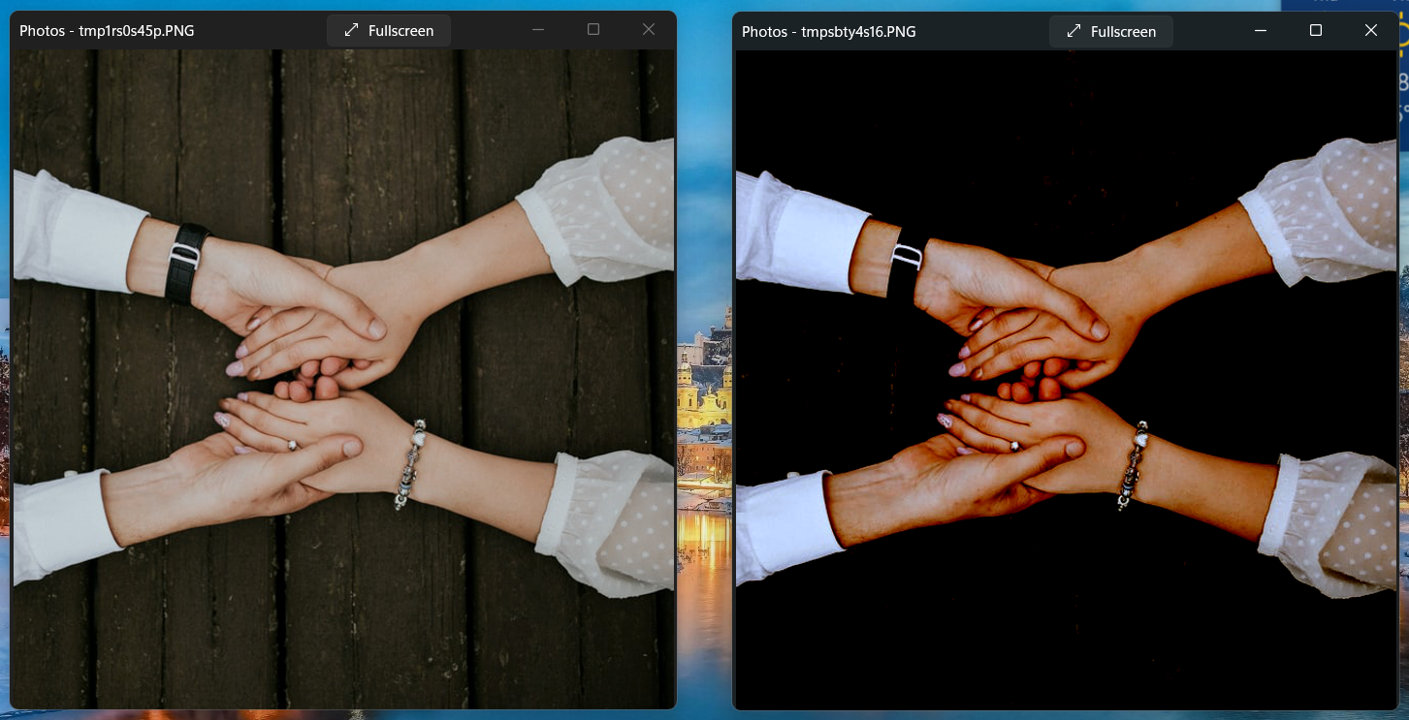

**Figure 10.1** Output of Write a program to increase the contrast of the image using contrast Stretching (Left): Original Image and (Right): Contrast Stretched Image.

* As we can see in above figure 9.1 we have original image on the left and the contrast stretched image on the right.
* Here we have used PIL (Python Image library) in our program for increasing the contrast of our image using contrast stretch technology.
* Here we have used .point() function provided by the PIL library to do point operation on every pixel of each color channel contained in the image which is necessary. This .point() function takes a function as its argument.
* Here to do contrast stretching we have first split the image into its different channels. Here as our input image is an RGB image so we split our input image into sperate red, green , and blue channels.
* After that we have defined a separate function for each channel of image. This function specifies the implementation of formula of contrast stretching. that is required for doing contrast stretching of the each pixel value of image color channel. These functions only take one argument as input and that argument is the value of the pixel that we want to transform. This function returns the modified pixel value calculated from the contrast stretching formula.
* Our .point() function takes this above mentioned function as its argument to do point transformations on each pixel of image. We apply this .point() function on the pixels of separated color channels of the input image.
* After doing .point() operation we get modified or we can say contrast stretched value of each color channels of image.
* After that we merge these newly modified color channels of image to generate the new image that has its contrast increased.
* In this new image value of every pixel is increased to a maximum value as specified in the implementation functions of contrast function for each separate color channel of the input image.

Q11. Write a program to increase the contrast of the image using thresholding.

Thresholding is a process of extracting a part of an image which contains information. In this transformation, one threshold level is set and pixel values below threshold are to be set as 0 and above values are set as 255.

Following is the program to increase the contrast of the image using thresholding.

Program:

**import** cv2  
*# This import statement is used to import the python packages or # modules that required by our program.*  
*# Here we are importing cv2 module which is used for image reading # and also for displaying image in our program.*  
*# opencv read the images a numpy arrays.*  
  
img = cv2.imread(**"imagetr.jpg"**)  
*# cv2.imread() function is used to read and load image files stored # in your system.*  
  
img = cv2.resize(img, (320, 320))  
*# cv2.resize() function resizes the input image into the provided # height and width.*  
  
imgGrey = cv2.cvtColor(img, cv2.COLOR_BGR2GRAY)  
*# cv2.ctvColor() function converts the input image from one color space to* *another color space by provided the desired argument.*  
*# Here we are converting image from BGR color space to a greyscale # image.*  
  
(thresh, imgIncreasedContrast) = cv2.threshold(img, 123, 255, cv2.THRESH_BINARY)  
*# cv2.threshhold() function applies fixed-level thresholding to a*  
*# multiple-channel array (which is our greyscale image (imgGrey) # here.*  
*# This function is typically used to get a bi-level (binary) image*  
*# out of a grayscale image or for removing a noise, that is,*  
*# filtering out pixels with too small or too large values.*  
*# There are several types of thresholding supported by the function.*  
*# They are determined by type parameter.*  
  
cv2.imshow(**"orignal image"**, img)  
cv2.imshow(**"Greyscale image of input image"**, imgGrey)  
cv2.imshow(**"Increased contrast Image"**, imgIncreasedContrast)  
*# cv2.imshow() function is used to display the image in the # specified window.*  
  
cv2.waitKey(0)  
*# cv2.waitKey() function waits for a couple of seconds as specified # by the user for a key event.*  
*# Here as we have defined zero here then the waitKey() function # waits infinitely for a key event to happen.*  
  
cv2.destroyAllWindows()  
*# This cv2.destroyAllWindows() function destroys all the opened GUI # windows which are opened* *by this particular program.*

Output:

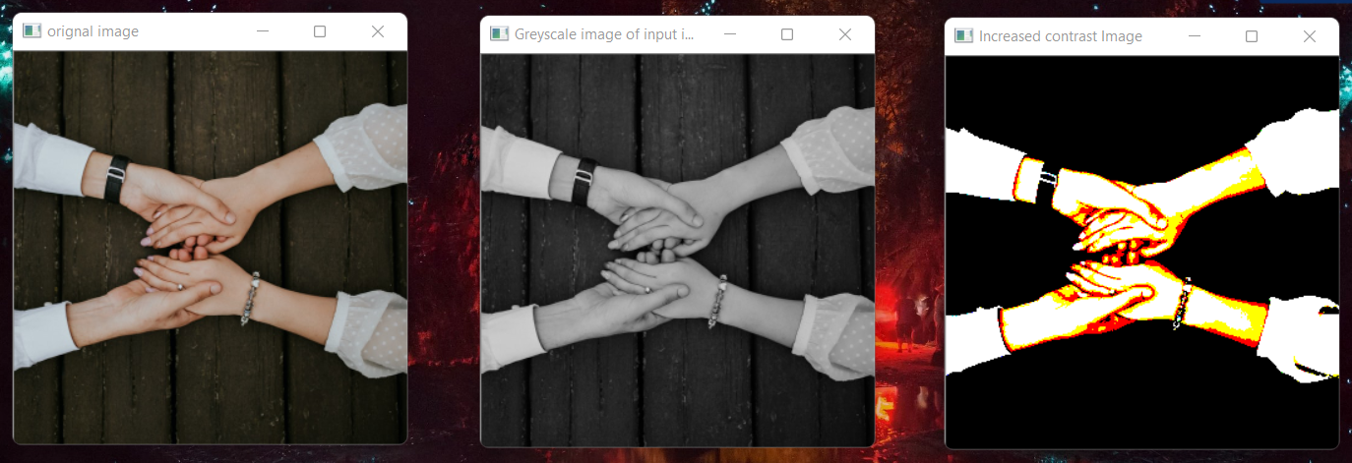

**Figure 11.1 Output of** Write a program to increase the contrast of the image using thresholding (Left): Original Image, (Middle): Greyscale image of the input image, and (Right): Output image with Increased contrast.

* Here as you can in the Figure 10 on left, we have our original input image whose contrast we want to increase, in the middle we have greyscale image of our input image that is required by thresholding function to do , and on left we have the output image having its contrast increased.
* Here we are using **cv2.threshold()** function for increasing the contrast of the image.
* Here firstly we convert the input RGB image into greyscale image because **cv2.threshold(img, 123, 255,cv2.THRESH_BINARY)**function takes a greyscale image as input image to work on.
* After that we use **cv2.threshold(img, 123, 255, cv2.THRESH_BINARY)** function that takes 4 arguments. The first argument is the greyscale image, second argument is the threshold value used for classifying pixel values of image, third argument is the maximum pixel value which is assigned to the pixel value exceeding the threshold value and the fourth argument specifies type of Thresholding we want to use.
* Here we have specified the thresholding value as 127 and the maximum pixel value as 255. Also, here as fourth argument we have specified cv2.THRESH_BINARY as the thresholding technique we are using here.
* According to **cv2.THRESH_BINARY** thresholding technique the pixel values in image that are smaller than the specified threshold value gets set to zero and all the pixel values in the image that are larger than the specified thresholding values gets set to the specified maximum value .
* This function returns the tuple in which one value is the thresholding value used in the function and the other is the numpy array of the **Thresholded image.**
* This thresholded image that we get has an increased contrast value.

Q12. Write a python code to enhance an image using Gray level slicing (with and without background).

Grey level slicing is also called as intensity level slicing. It is a very important technique used in image processing. It manipulates group of intensity levels, or we can say grey levels in an image up to specific range by diminishing rest or by leaving them alone. This type of image transformation is mostly used in medical images and satellite images such as X-ray flaws, CT scan.

There are two approaches by which we can do grey level slicing:

* Grey level slicing with background
* Grey level slicing without background

Here we discuss Grey level Slicing with background. In this approach ,we brighten (or darkens) the desired range of intensity values but preserves the background / other intensity levels and gray-level tonalities in the image.

1. Following is the program to enhance an image using Gray level Slicing with background.

Program:

**import** cv2  
**import** numpy **as** np  
**from** matplotlib **import** pyplot **as** plt  
*# This import statement is used to import the python packages or*   
*# modules that required by our program.*  
*# Here we are importing cv2 module which is used for img*   
*# reading and also for displaying img in our program.*  
*# opencv read the images a numpy arrays.*  
*# Here we are also importing matplotlib.pyplot which provides an # implicit, MATLAB-like, way of plotting.*  
*# It also used to opens figures on your screen, and also acts as the # figure GUI manager.*  
*# pyplot module is mainly intended for interactive plots and simple # cases of programmatic plot generation.*  
*# Here we are using matplotlib.pyplot to display title on our output img.*  
  
  
img = cv2.imread(**'imagetr.jpg'**, 0)  
*# cv2.imread() function is used to read and load img*   
*# files stored in your system.*  
  
x, y = img.shape  
  
z = np.zeros((x, y))  
**for** i **in** range(0, x):  
 **for** j **in** range(0, y):  
 **if** 50 < img[i][j] < 150:  
 z[i][j] = 255  
 **else**:  
 z[i][j] = img[i][j]  
slicedImage = np.hstack((img, z))  
*# np.hstack() is used to concatenating the numpy arrays.*  
  
plt.title(**"(a) Orignal img and (b) Gray level sliced img with background"**)  
*# Here plt.title() function is used to display title on the output # image plot.*  
  
plt.imshow(slicedImage, **'gray'**)  
*# plt.imshow() is used to displaying the images*  
  
plt.show()  
*# io.show() Launch the event loop of the current gui*   
*# plugin, and display all pending images, queued via imshow.*  
*# A call to show will block execution of code until all*   
*# windows have been closed.*   
*# This io.show() is required when we are using imshow in # non-interactive scripts.*

Output:

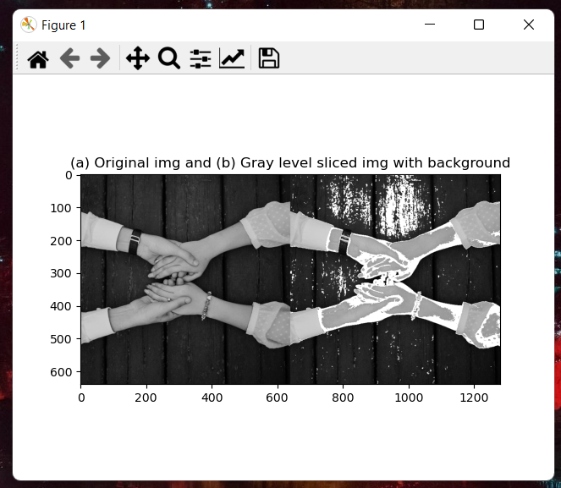

**Figure 12.1** Output of Write a python code to enhance an image using Gray level slicing with background. (Left): Original Image, and (Right): Gray Level sliced image with background

* As we can see in the above Figure 11.1 on left, we have the original image and on the right side we have our output image which is a gray level sliced image with background.
* Here in our program, we have chosen from the image the range of intensity values from 50 – 150 to work on. We have brightened the intensity value to 255 that falls between this intensity range of 50 -150 but we have not modified the other intensities that does not comes in our specified intensity range.

Now we will discuss about Gray level slicing without background. In this approach ,we highlight (brighten) the desired range of intensity values and reduces( or darken) the background / other all the other intensity levels present in the image to a constant level.

1. Following is the program to enhance an image using Gray level Slicing with background.

Program:

**import** cv2  
**import** numpy **as** np  
**from** matplotlib **import** pyplot **as** plt  
*# This import statement is used to import the python packages or*   
*# modules that required by our program.*  
*# Here we are importing cv2 module which is used for img*   
*# reading and also for displaying img in our program.*  
*# opencv read the images a numpy arrays.*  
*# Here we are also importing matplotlib.pyplot which provides an # implicit, MATLAB-like, way of plotting.*  
*# It also used to opens figures on your screen, and also acts as the # figure GUI manager.*  
*# pyplot module is mainly intended for interactive plots and simple # cases of programmatic plot generation.*  
*# Here we are using matplotlib.pyplot to display title on our output img.*  
  
  
img = cv2.imread(**'imagetr.jpg'**, 0)  
*# cv2.imread() function is used to read and load img*   
*# files stored in your system.*  
  
x, y = img.shape  
  
z = np.zeros((x, y))  
**for** i **in** range(0, x):  
 **for** j **in** range(0, y):  
 **if** 50 < img[i][j] < 150:  
 z[i][j] = 255  
 **else**:  
 z[i][j] =0  
slicedImage = np.hstack((img, z))  
*# np.hstack() is used to concatenating the numpy arrays.*  
  
plt.title(**"(a) Orignal img and (b) Gray level sliced img without background"**)  
*# Here plt.title() function is used to display title on the output # image plot.*  
  
plt.imshow(slicedImage, **'gray'**)  
*# plt.imshow() is used to displaying the images*  
  
plt.show()  
*# io.show() Launch the event loop of the current gui*   
*# plugin, and display all pending images, queued via imshow.*  
*# A call to show will block execution of code until all*   
*# windows have been closed.*   
*# This io.show() is required when we are using imshow in # non-interactive scripts.*

Output:

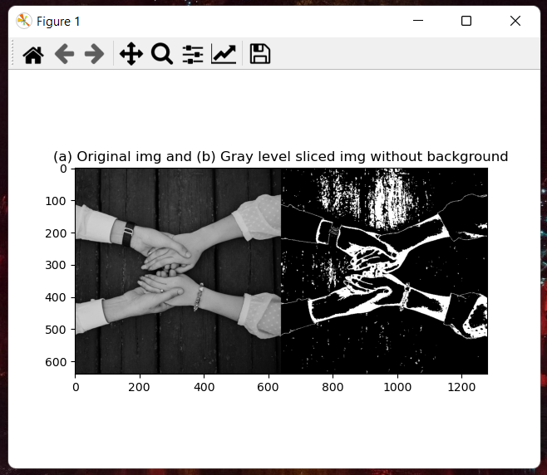

**Figure 12.1 (a)** Output of Write a python code to enhance an image using Gray level slicing with background. (Left): Original Image, and (Right): Gray Level sliced image without background

* As we can see in the above Figure 11.1 (a) on left, we have the original image and on the right side we have our output image which is a gray level sliced image without background.
* Here in our program, we have chosen from the image the range of intensity values from 50 – 150 to work on. We have brightened the intensity value to 255 that falls between this intensity range of 50 -150 and we have reduced (or darken) the other intensities that does not comes in our specified intensity range to 0.

Q13. Write a python code to improve the dynamic range of an input image using Log transformation or power law transformation.

Firstly, we discuss what is dynamic range of an image. The dynamic range of an image is simply the ratio between the brightest and darkest pixel values of an image. An image of fixed bit depth thus has a fixed maximum dynamic range. Dynamic range of an image also specifies how well we are able to see various details present in an image. If the picture has a high dynamic range then we will be able to see all the details contained in the picture very clearly. But if the dynamic range of an image is not low then we will not be able to see all the details in an image.

So. Increasing the dynamic range is very important if we want to get more details in our pictures. We can increase the dynamic range of an image by manipulating with contrast of the image( which means by either increasing or decreasing the contrast).

Here we use power law transformation for increasing the dynamic range of our image.

Power law transformation: power law transformation is one of the types of intensity transformation function. It is also known as gamma correlation because power law transformation deals with gamma levels (*)*in the images*.* The transformation equation for power law transformation is as follows:

Where, = positive constants

= input gray levels (contained in the input image)

= Output gray levels

The following figure 12.1 shows plots of as a function of for various values of . As we can see from the figure that the Power-law curves with fractional values( like 0.10, 0.20, 0.67,etc) of map a narrow range of dark input values into a wider range of output values, with the opposite being true for higher values( like 1.5, 2.5, 5.0 etc) of input levels of .

So, we can conclude that we can obtain different value of (grey levels) simply by varying value.

Also, we can conclude that when , darker regions of image are enhanced, and brighter regions are compressed and observe the opposite in case of . And, when , there is no transformation.

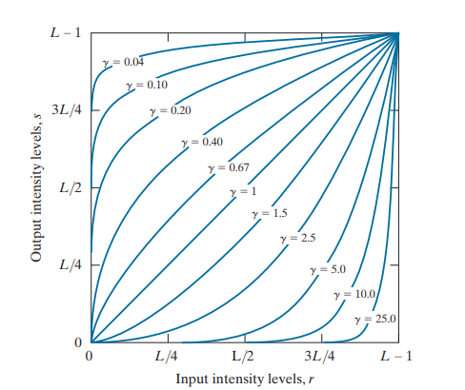

**Figure 13.1** Power Law Transformation curves**.**

Following is the program to improve the dynamic range of an input image using power law transformation.

Program:

**import** cv2  
**import** numpy **as** np  
*# This import statement is used to import the python packages or*  
*# modules that required by our program.*  
*# Here we are importing cv2 module which is used for img*  
*# reading and also for displaying img in our program*  
*# Here we are also importing numpy which is used to do*  
*# manipulation on array objects.*  
*# Here we are using this library to manipulate our*  
*# numpy array of image as Opencv read the images a*  
*# numpy arrays.*  
image = cv2.imread(**'imagetr.jpg'**)  
*# cv2.imread() function is used to read and load img files stored in # your system.*  
  
image = cv2.resize(image, (320, 320))  
*# The above cv2.resize() function is used to resize the img*  
*# src down to or up to the specified size.*  
  
cv2.imshow(**"orignal image"**, image)  
*# cv2.imshow() function is used to display the img in the specified # window.*  
  
*# list of Gamma values to be taken*  
**for** gammaValues **in** [1, 1.5, 1.8, 2.5, 5.0]:  
 *# Applying the power law transformation on image numpy array.*  
 gammaTransformedImg = np.array(255 * (image / 255) ** gammaValues, dtype=**'uint8'**)  
  
 cv2.imshow(**'imgWithGammaValue = '** + str(gammaValues), gammaTransformedImg)  
 *# cv2.imshow() function is used to display the img in the # specified window.*  
  
cv2.waitKey(0)  
*# cv2.waitKey() function waits for a couple of seconds*  
*# as specified by the user for a key event.*  
*# Here as we have defined zero here then the waitKey()*  
*# function waits infinitely for a key event to happen.*  
  
cv2.destroyAllWindows()  
*# This cv2.destroyAllWindows() function destroys all the opened GUI # windows which are opened* *by this particular program.*

Output:

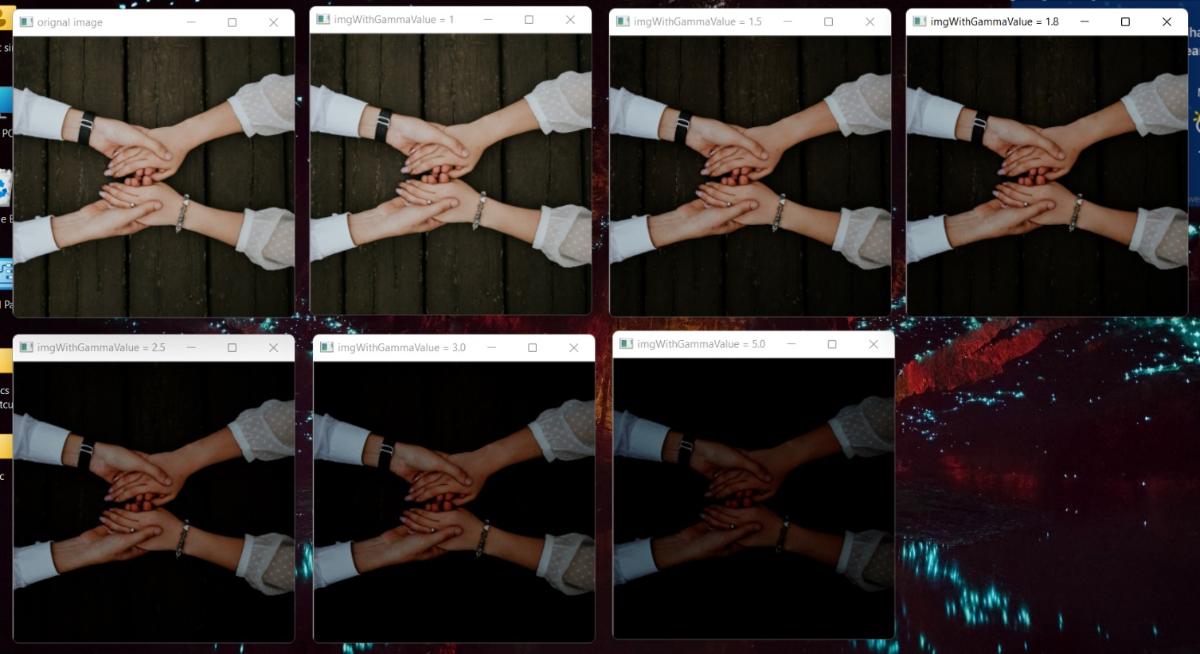

**Figure 13.1 (a)** Output of Write a python code to improve the dynamic range of an input image using power law transformation. (**1):** Original Image, (**2):** Output image with Gamma value = 1, (**3):** Output image with Gamma value = 1.5, (**4):** Output image with Gamma value = 1.8, (**5):** Output image with Gamma value = 2.5, (**6):** Output image with Gamma value = 3.0 and (**7):** Output image with Gamma value = 5.0

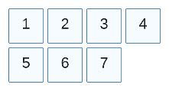

* Here as we can see in above figure 12.1 (a) we have multiple windows each of which containing a particular image output in it. The first image is the original Image, second image is the output image that we get when we define Gamma () , Third image is output image that we get when we define Gamma () , Fourth image is the output image that we get when we define Gamma (.8) , Fifth image is the output image that we get when we define Gamma , Sixth image is the output image that we get when we define Gamma ( and the Seventh image is the Output image with Gamma
* When we observe these outputs clearly, we can see that when the value of gamma is 1 then the output image is same as the original image. So, we can conclude that in case of no transformation is applied on the image.
* Also, we can observe from the output that as we are increasing the gamma value our image starts looking darker which means the contrast of our image keeps on getting to increase. Also, as the contrast of our image increases the details in our image starts getting clearer which means that the dynamic range of our image improves. But as we can see in out output that when we use the contrast of our increases drastically that makes the image darker. As we know that dynamic range is the ratio between the brightest and darkest pixel values of an image. So here as the contrast increases drastically this ratio also gets disturbed which in simple words means that dynamic range of our image gets decreased.
* So in to get a image with a good dynamic range we have to vary the gamma values and observe the output. And when the output seems good then we should select that gamma value.
* Here in the above figure 12.1 (a) The dynamic range of our image keeps on getting improved until we reach gamma value of 1.8 after that when we take gamma value of 2.5 ,3.0 and 5.0 our image gets darker.
* So, we can say that from Figure 12.1(a) the image with Gamma value = 1.8 has the best dynamic range than the other.

Q14. Write a python code to do Image filtering (Sobel, Laplacian, Roberts and Prewitt)

Following is the program to Image filtering (Sobel, Laplacian, Roberts and Prewitt):

**import** cv2  
**import** numpy **as** np  
**from** matplotlib **import** pyplot **as** plt  
**import** argparse  
*# This import statement is used to import the python packages or*  
*# modules that required by our program.*  
*# Here we are importing cv2 module which is used for image*  
*# reading and also for displaying images.*  
*# opencv read the images a numpy arrays.*  
*# Here also we are importing matplotlib.pyplot*  
*# opencv read the images a numpy arrays.*  
*# Here we are also importing matplotlib.pyplot*  
*# which provides an implicit, MATLAB-like, way of plotting.*  
*# It also used to opens figures on your screen,*  
*# and also acts as the figure GUI manager.*  
*# Pyplot module is mainly intended for*  
*# interactive plots and simple cases of*  
*# programmatic plot generation.*  
*# Here we are also importing numpy is*  
*# used to do manipulation on array object*  
*# Here we are also importing argparse*  
*# which is a command-line argument*  
*# parsing library which we are using here*  
*# to parse path to our image files here.*  
ap = argparse.ArgumentParser()  
ap.add_argument(**"-i"**, **"--InputImage"**, required=**False**, default=**"imagetr.jpg"**, help=**"path to input image file to be read"**)  
args = vars(ap.parse_args())  
  
img = cv2.imread(args[**"InputImage"**])  
*# The above function cv2.imread is used*  
*# to read the images from the disk.*  
  
imgOrignal = cv2.cvtColor(img, cv2.COLOR_BGR2RGB)  
*# Here in the above statement we are converting our*  
*# image from the BGR color space to the RGB*  
*# color space.*  
  
imgGrey = cv2.cvtColor(img, cv2.COLOR_RGB2GRAY)  
*# Here in the above statement we are converting our*  
*# image from the RGB color space to the Greyscale image*  
*# because filters can only be applied on a greyscale image.*  
  
imgBlured = cv2.GaussianBlur(imgGrey, (3, 3), 0)  
*# In the above statement we are applying Gaussian Blur*  
*# to our input image. we are doing this to remove the*  
*# noise from our image.*  
  
  
*# The below function contains the logic for constructing*  
*# and applying the robert filter on our input image.*  
**def** robert_filter(input_image):  
 *# Robert filter Kernel construction*  
 kernelx = np.array([[-1, 0], [0, 1]], dtype=int)  
 kernely = np.array([[0, -1], [1, 0]], dtype=int)  
  
 *# Applying the above made filter to our greyscale image*  
 x = cv2.filter2D(input_image, cv2.CV_16S, kernelx)  
 y = cv2.filter2D(input_image, cv2.CV_16S, kernely)  
  
 *# Following statements calculates the absolute value and # converts the result into 8-bit integer.*  
 abs_x = cv2.convertScaleAbs(x)  
 abs_y = cv2.convertScaleAbs(y)  
  
 *# The below function cv2.addWeighted() calculates the weighted # sum of two arrays.*  
 filtered_img = cv2.addWeighted(abs_x, 0.5, abs_y, 0.5, 0)  
 **return** filtered_img  
  
*# The below function contains the logic*  
*# for constructing and applying the*  
*# sobel filter on our input image.*  
**def** sobel_filter(input_image):  
 *# Sobel filter Kernel construction*  
 kernelx = np.array([[-1, 0, 1], [-2, 0, 2], [-1, 0, 1]], np.float32)  
 kernely = np.array([[1, 2, 1], [0, 0, 0], [-1, -2, -1]], np.float32)  
  
 *# Applying the above made Sobel filter to our greyscale image*  
 x = cv2.filter2D(input_image, cv2.CV_16S, kernelx)  
 y = cv2.filter2D(input_image, cv2.CV_16S, kernely)  
  
 *# Following statements calculates the*  
 *# absolute value and converts the*  
 *# result into 8-bit integer.*  
 abs_x = cv2.convertScaleAbs(x)  
 abs_y = cv2.convertScaleAbs(y)  
  
 *# The below function cv2.addWeighted()*  
 *# calculates the weighted sum of two arrays.*  
 filtered_img = cv2.addWeighted(abs_x, 0.5, abs_y, 0.5, 0)  
 **return** filtered_img  
  
*# The below function contains the logic for constructing*  
*# and applying the Prewitt filter on our input image.*  
**def** prewitt_filter(input_image):  
 *# Prewitt filter Kernel construction*  
 kernelx = np.array([[-1, -1, -1], [0, 0, 0], [1, 1, 1]], np.float32)  
 kernely = np.array([[-1, 0, 1], [-1, 0, 1], [-1, 0, 1]], np.float32)  
  
 *# Applying the above made Prewitt filter to our greyscale image*  
 x = cv2.filter2D(input_image, cv2.CV_16S, kernelx)  
 y = cv2.filter2D(input_image, cv2.CV_16S, kernely)  
  
 *# Following statements calculates the absolute value and # converts the result into 8-bit integer.*  
 abs_x = cv2.convertScaleAbs(x)  
 abs_y = cv2.convertScaleAbs(y)  
  
 *# The below function cv2.addWeighted() calculates the weighted # sum of two arrays.*  
 filtered_img = cv2.addWeighted(abs_x, 0.5, abs_y, 0.5, 0)  
 **return** filtered_img  
  
*# The below function contains the logic for*  
*# applying the laplacian filter on our input image.*  
**def** laplacian_filter(input_image):  
 *# Here in the below statement we are*  
 *# applying laplacian filter to our image.*  
 *# For applying Laplacian filter to our image*  
 *# we are using cv2.Laplacian() function.*  
 xy = cv2.Laplacian(imgBlured, cv2.CV_16S, 3)  
 abs_xy = cv2.convertScaleAbs(xy)  
  
 *# The below function cv2.addWeighted() calculates*  
 *# the weighted sum of two arrays.*  
 filtered_img = abs_xy  
  
 *# In the below return statement we are*  
 *# returning the ndarray of our filtered image.*  
 **return** filtered_img  
  
  
robertFilteredImg = robert_filter(imgBlured)  
sobelFilteredImg = sobel_filter(imgBlured)  
laplacianFilteredImg = laplacian_filter(imgBlured)  
prewittFilteredImg = prewitt_filter(imgBlured)  
  
imagesTitle = [**"Orignal Image"**, **"Robert Filtered Image"**, **"Sobel Filtered Image"**, **"laplacian Filtered Image"**,**"Prewitt Filterd Image"**]

imagesBoth = [imgOrignal, robertFilteredImg, sobelFilteredImg, laplacianFilteredImg, prewittFilteredImg]  
  
**for** i **in** range(5):  
 plt.subplot(2, 3, i + 1), plt.imshow(imagesBoth[i], **'gray'**)  
 plt.title(imagesTitle[i])  
  
plt.show()

Output:

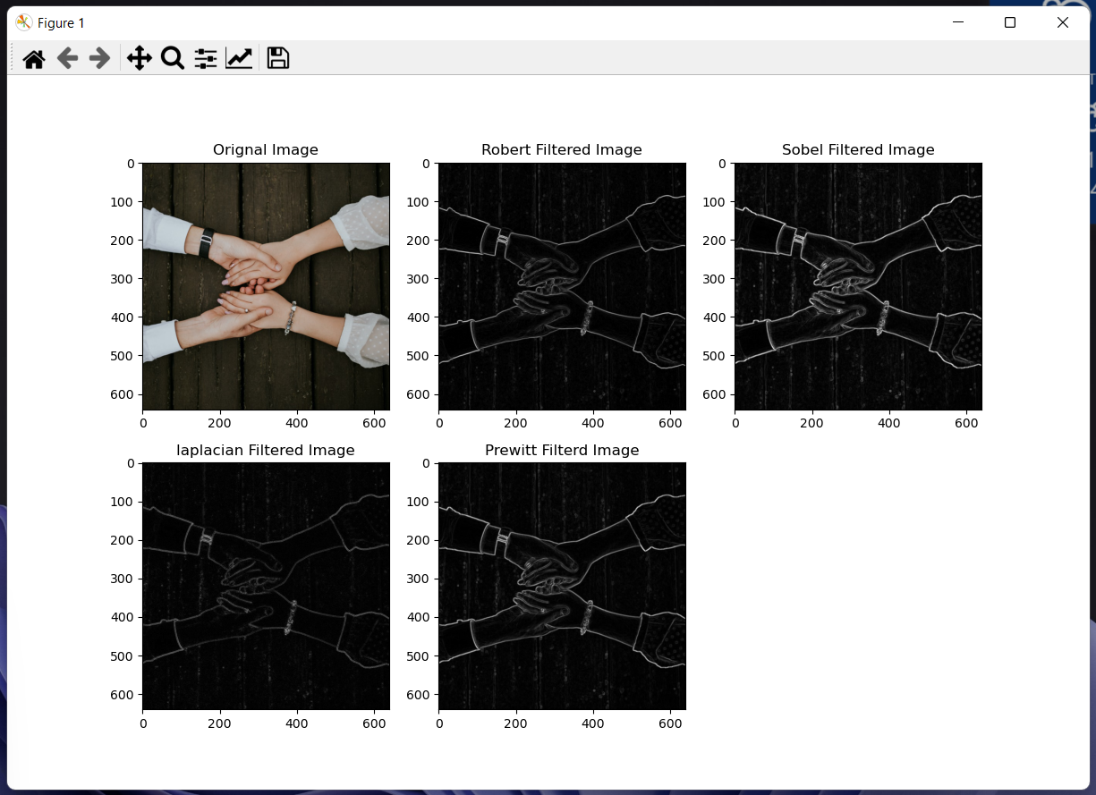

**Figure 14.1** Output of applying different Image filters (Sobel, Laplacian, Robert, and Prewitt) on the input image. 1) Original image, 2)Output image after applying Robert Filter on input image, 3)Output image after applying Sobel Filter on input image. 4)Output image after applying Laplacian Filter on input image and 5)Output image after applying Prewitt Filter on input image

,

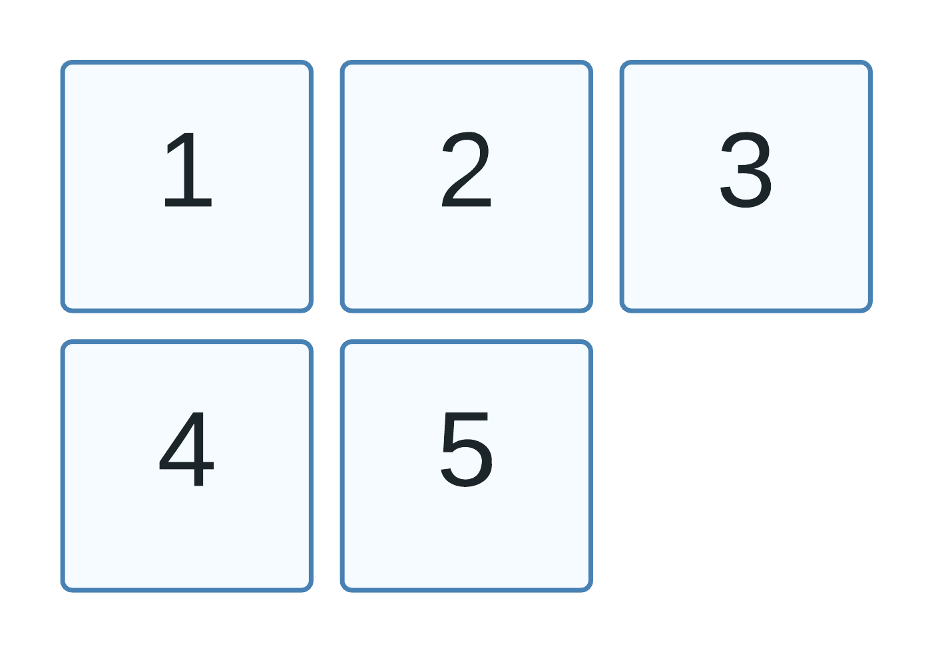

Q15. Write a python code to do addition and removal of noise (noise filtering) in images (salt and pepper).

Following is the program to do addition and removal of noise (noise filtering) in images (salt and pepper):

**import** cv2  
**from** matplotlib **import** pyplot **as** plt  
**import** random  
**import** argparse  
*# This import statement is used to import the python packages or*  
*# modules that required by our program.*  
*# Here we are importing cv2 module which is used for image*  
*# reading and also for displaying images.*  
*# opencv read the images a numpy arrays.*  
*# Here also we are importing matplotlib.pyplot*  
*# opencv read the images a numpy arrays.*  
*# Here we are also importing matplotlib.pyplot*  
*# which provides an implicit, MATLAB-like, way of plotting.*  
*# It also used to opens figures on your screen,*  
*# and also acts as the figure GUI manager.*  
*# Pyplot module is mainly intended for*  
*# interactive plots and simple cases of*  
*# programmatic plot generation.*  
*# Here we are also importing random package*  
*# which is used random numbers within the given range.*  
*# Here we are also importing argparse*  
*# which is a command-line argument*  
*# parsing library which we are using here*  
*# to parse path to our image files here.*  
  
ap = argparse.ArgumentParser()  
ap.add_argument(**"-i"**, **"--InputImage"**, required=**False**, default=**"imagetr.jpg"**, help=**"path to input image file to be read"**)  
args = vars(ap.parse_args())  
  
imgOrignal = cv2.imread(args[**"InputImage"**])  
imgOrignal = cv2.cvtColor(imgOrignal, cv2.COLOR_BGR2RGB)  
*# Here in the above statement we are converting our*  
*# image from the BGR color space to the RGB*  
*# color space.*  
  
imgGrey = cv2.cvtColor(imgOrignal, cv2.COLOR_RGB2GRAY)  
*# Here in the above statement we are converting our*  
*# image from the RGB color space to the Greyscale image*  
  
*# The below function contains the logic*  
*# for adding salt and pepper noise in*  
*# our input image.*  
**def** salt_and_pepper_noise(input_image):  
 *# the following function.shape is used for*  
 *# getting the dimensions of the image*  
 row, col = input_image.shape  
  
 *# Here we are randomly picking number of*  
 *# pixels in the image for coloring them*  
 *# white.*  
 *# This below randon.randint() function pick a random number*  
 *# between the given values two values here we have taken 100 and # 8000*  
 number_of_pixels = random.randint(200, 8000)  
 **for** i **in** range(number_of_pixels):  
 *# Pick a random pont on y coordinate*  
 y_coordinate = random.randint(0, row - 1)  
  
 *# Pick a random point on x coordinate*  
 x_coordinate = random.randint(0, col - 1)  
  
 *# Here we are assigning that pixel white color*  
 input_image[y_coordinate][x_coordinate] = 255  
  
 *# Here we are randomly picking number of*  
 *# pixels in the image for coloring them*  
 *# black.*  
 *# This below randon.randint() function pick a random number*  
 *# between the given values two values here we have taken 200 and # 8000*  
 number_of_pixels = random.randint(200, 8000)  
 **for** i **in** range(number_of_pixels):  
 *# Pick a random point y coordinate*  
 y_coordinate = random.randint(0, row - 1)  
  
 *# Pick a random point on x coordinate*  
 x_coordinate = random.randint(0, col - 1)  
  
 *# Here we are assigning that pixel black color*  
 input_image[y_coordinate][x_coordinate] = 0  
  
 *# This below statement returns the output*  
 *# image ndarray with salt and pepper noise in it.*  
 **return** input_image  
  
*# The below function contains the logic*  
*# for removal of salt and pepper noise from*  
*# our image.*  
**def** salt_and_pepper_noise_removed(input_image):  
 *# This below cv2.medianBlur() function*  
 *# applies the median filter with a*  
 *# kernel specified size which is here set*  
 *# to 3 as per our requirements to our image*  
 *# that contains salt and pepper noise.*  
 median_blured_image = cv2.medianBlur(input_image, 3)  
  
 *# This below statement returns the output*  
 *# image ndarray with salt and pepper noise*  
 *# removed from it.*  
 **return** median_blured_image  
  
  
noisedImage = salt_and_pepper_noise(imgGrey)  
removedNoiseImage = salt_and_pepper_noise_removed(noisedImage)  
  
imagesTitle = [**"Orignal Image"**, **"Noised(Salt and Pepper) Image"**, **"Removed noise Image"**]  
imagesBoth = [imgOrignal, noisedImage, removedNoiseImage]  
  
**for** i **in** range(3):  
 plt.subplot(1, 3, i + 1), plt.imshow(imagesBoth[i], **'gray'**)  
 plt.title(imagesTitle[i])  
  
plt.show()

Output:

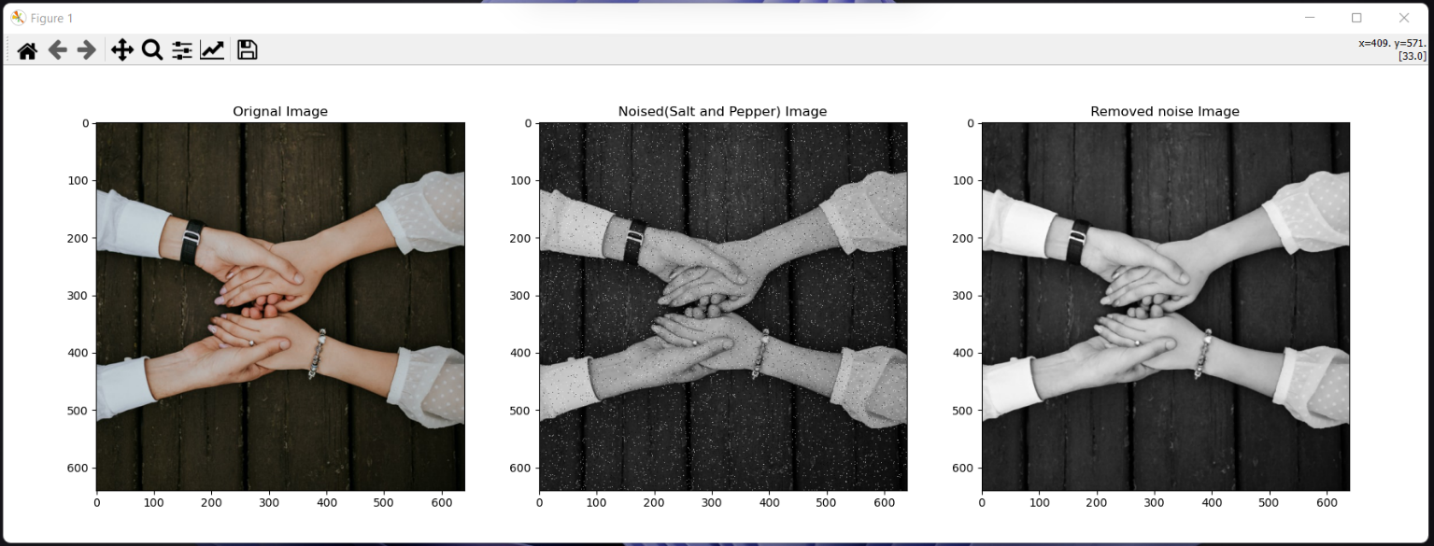

**Figure 6.1** Output of program for the addition and removal of noise (noise filtering) in images (salt and pepper) (Left): Original Image, (Middle): Salt and Pepper noise added to the original image, and (Right): Image with salt and pepper noise removed

Q16. Conversion of color models: converting colors from:

* RGB to HSI,
* HSI to RGB,
* RGB to CMY and
* CMY to RGB etc.

Following is the program to convert the image from RGB(Red, Green, Blue) color space to HIS(Hue, Saturation, Intensity) color space and vice versa , as well to convert image from RGB color space to CMY(Cyan, Magenta, Yellow) color space and vice-versa:

**import** cv2  
**import** numpy **as** np  
**import** argparse  
*# This import statement is used to import the python packages or*  
*# modules that required by our program.*  
*# Here we are importing cv2 module which is used for image*  
*# reading and also for displaying images in our program.*  
*# opencv read the images a numpy arrays.*  
*# opencv read the images a numpy arrays.*  
*# Here we are also importing numpy is*  
*# used to do manipulation on array object*  
*# (which are Images here).*  
*# Here we are also importing argparse*  
*# which is a command-line argument*  
*# parsing library which we are using here*  
*# to parse path to our image files here.*  
  
ap = argparse.ArgumentParser()  
ap.add_argument(**"-i"**, **"--InputImage"**, required=**False**, default=**"imagetr.jpg"**, help=**"path to input image file to be read"**)  
args = vars(ap.parse_args())  
  
img = cv2.imread(args[**"InputImage"**])  
*# The above function cv2.imread is used*  
*# to read the images from the disk.*  
  
*# The below Scale Percentage represents*  
*# the scale of original size of image we want.*  
scale_percent = 50  
width = int(img.shape[1] * scale_percent / 100)  
height = int(img.shape[0] * scale_percent / 100)  
dimensions = (width, height)  
img = cv2.resize(img, dimensions, cv2.INTER_AREA)  
*# The above function cv2.resize is used*  
*# to resize the images as per our*  
*# requirements(HxW).*

img_orignal_rgb = cv2.cvtColor(img, cv2.COLOR_BGR2RGB)  
*# Here in the above statement we are converting our*  
*# image from the BGR color space to the RGB*  
*# color space.*  
  
*# This below function Defines the code for converting*  
*# an image from RGB(Red, Green, and Blue) color space*  
*# to HSI(Hue, Saturation , and Intensity) color space.*  
  
  
**def** RGB2HSI(input_rgb_image):  
 *# Below statement is used to*  
 *# separate the individual R, G and B*  
 *# channels present in input image.*  
 r, g, b = input_rgb_image[:, :, 0], input_rgb_image[:, :, 1], input_rgb_image[:, :, 2]  
  
 *# Below statement is used to calculate*  
 *# the sum of all the channels i.e; R, G and B*  
 sm = np.sum(input_rgb_image, axis=2)  
  
 *# Below statement calculates the intensity value from RGB image.*  
 i = sm / 3  
  
 *# Below statement calculates the saturation value from RGB # image.*  
 s = 1 - (np.min(input_rgb_image, axis=2) / sm * 3)  
  
 r = r.astype(np.float16)  
 g = g.astype(np.float16)  
 b = b.astype(np.float16)  
  
 num = (2 * r - g - b)  
 den = 2 * np.sqrt(np.square(r - g) + (r - b) * (g - b))  
  
 t = np.ones(b.shape, dtype=int)  
 t = np.divide(num, den, where=den != 0)  
 t = np.degrees(np.arccos(t))  
  
 *# Below statement is used to calculate the value of Hue.*  
 h = np.where(b > g, 360 - t, t)  
  
 hsi_image = np.dstack([h, s, i])  
  
 *# Here in the below return statement we*  
 *# are returning ndarray of our HSI image.*  
 **return** hsi_image  
  
*# This below function Defines the code for converting*  
*# an image from HSI(Hue, Saturation , and Intensity) color space*  
*# to RGB(Red, Green, and Blue)color space.*  
  
  
**def** HSI2RGB(input_hsi_image):  
 h, s, i = input_hsi_image[:, :, 0], input_hsi_image[:, :, 1], input_hsi_image[:, :, 2]  
  
 *# initialise rgb matrices to zero*  
 r = np.zeros(h.shape, dtype=int)  
 g = np.zeros(h.shape, dtype=int)  
 b = np.zeros(h.shape, dtype=int)  
  
 *# In the following statements we are*  
 *# calculating r,g,b chanel values from h,s,i values.*  
 t = i * (1 - s)  
 b = np.where(h < 120, t, b)  
 r = np.where((120 <= h) & (h < 240), t, r)  
 g = np.where(h > 240, t, g)  
  
 t = s * (np.cos(np.radians(h)) / np.cos(np.radians(60 - h)))  
 r = np.where(h < 120, i * (1 + t), r)  
  
 t = s * (np.cos(np.radians(h - 120)) / np.cos(np.radians(180 - h)))  
 g = np.where((120 <= h) & (h < 240), i * (1 + t), g)  
  
 t = s * (np.cos(np.radians(h - 240)) / np.cos(np.radians(300 - h)))  
 b = np.where(h > 240, i * (1 + t), b)  
  
 g = np.where(h < 120, 3 * i - r - b, g)  
 b = np.where((120 <= h) & (h < 240), 3 * i - r - g, b)  
 r = np.where(h > 240, 3 * i - g - b, r)  
  
 *# In the below statement we are concatenated*  
 *# rgb channels and round to 8-bit unsigned*  
 *# integer (range 0-255)*  
 rgb_img = np.round(np.dstack([b, g, r]))  
 rgb_img = rgb_img.astype(np.uint8)  
  
 *# Here in the below return statement we*  
 *# are returning ndarray of our RGB image.*  
 **return** rgb_img  
  
*# This below function Defines the code for converting*  
*# an image from RGB(Red, Green, and Blue) color space*  
*# to CMY(Cyan, Magenta and Yellow) color space.*  
  
**def** RGB2CMY(input_rgb_image):  
 *# Below statement is used to*  
 *# separate the individual R, G and B*  
 *# channels present in input image.*  
 r, g, b = input_rgb_image[:, :, 0], input_rgb_image[:, :, 1], input_rgb_image[:, :, 2]  
  
 *# cmy_image = 1 - (rgb_image/255)*  
 c = 1 - (r / 255)  
 m = 1 - (g / 255)  
 y = 1 - (b / 255)  
  
 cmy_image = np.dstack([c, m, y])  
  
 *# Here in the below return statement we*  
 *# are returning ndarray of our CMY image.*  
 **return** cmy_image  
  
*# This below function Defines the code for converting*  
*# an image from CMY(Cyan, Magenta and Yellow) color space*  
*# to RGB(Red, Green, and Blue)color space.*  
  
  
**def** CMY2RGB(input_cmy_image):  
 *# rgb_image = 1 - input_cmy_image*  
 c, m, y = input_cmy_image[:, :, 0], input_cmy_image[:, :, 1], input_cmy_image[:, :, 2]  
 r = 1 - c  
 g = 1 - m  
 b = 1 - y  
 rgb_image = np.dstack([b, g, r])  
  
 *# Here in the below return statement we*  
 *# are returning ndarray of our CMY image.*  
 **return** rgb_image  
  
  
RGB_to_HSI_image = RGB2HSI(img_orignal_rgb)  
HSI_to_RGB_image = HSI2RGB(RGB_to_HSI_image)  
RGB_to_CMY_image = RGB2CMY(img_orignal_rgb)  
CMY_to_RGB_image = CMY2RGB(RGB_to_CMY_image)  
  
cv2.imshow(**"Original Image"**, img)  
cv2.imshow(**"RGB2HSI Image"**, RGB_to_HSI_image)  
cv2.imshow(**"HSI2RGB Image"**, HSI_to_RGB_image)  
cv2.imshow(**"RGB2CMY Image"**, RGB_to_CMY_image)  
cv2.imshow(**"CMY2RGB Image"**, CMY_to_RGB_image)  
*# The above statements are used to Display our*  
*# Original RGB image as well images with different*  
*# Color spaces.*  
  
cv2.waitKey(0)  
*# cv2.waitKey() function waits for a*  
*# couple of seconds as specified by the*  
*# user for a key event.*  
*# Here as we have defined zero here*  
*# then the waitKey() function waits*  
*# infinitely for a key event to happen.*  
  
cv2.destroyAllWindows()  
*# This cv2.destroyAllWindows() function*  
*# destroys all the opened GUI windows*  
*# which are opened by this particular*  
*# program.*

Output:

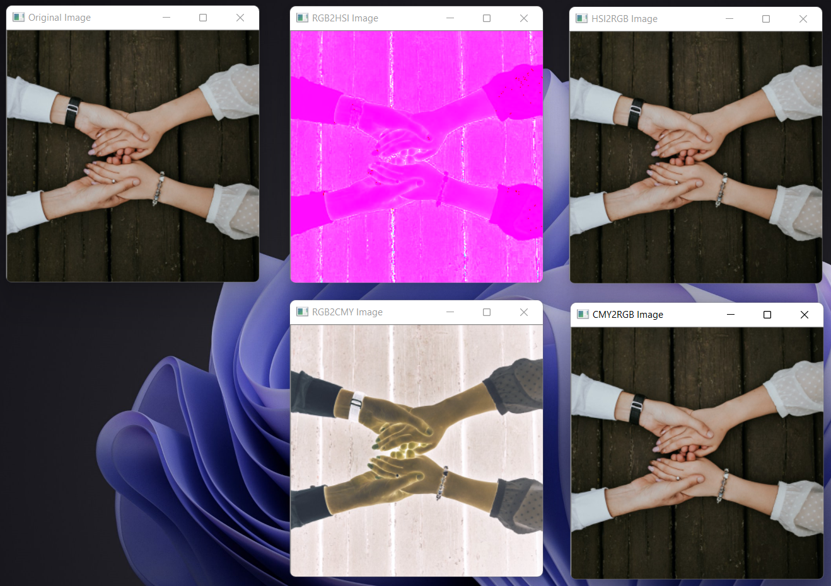

**Figure 16.1** Output of converting mage from one color model to another color model 1) Output image, 2) Output image after converting the original image from RGB color space to HSI color space, 3) Output image after converting the original image(which is converted into HSI color space in 2nd output image)from HSI color space to back RGB color space, 4) Output image after converting the original image from RGB color space to CMY color space and 5) Output image after converting the original image (which is converted into CMY color space as we see in 4th  output image) from HSI color space to back RGB color space

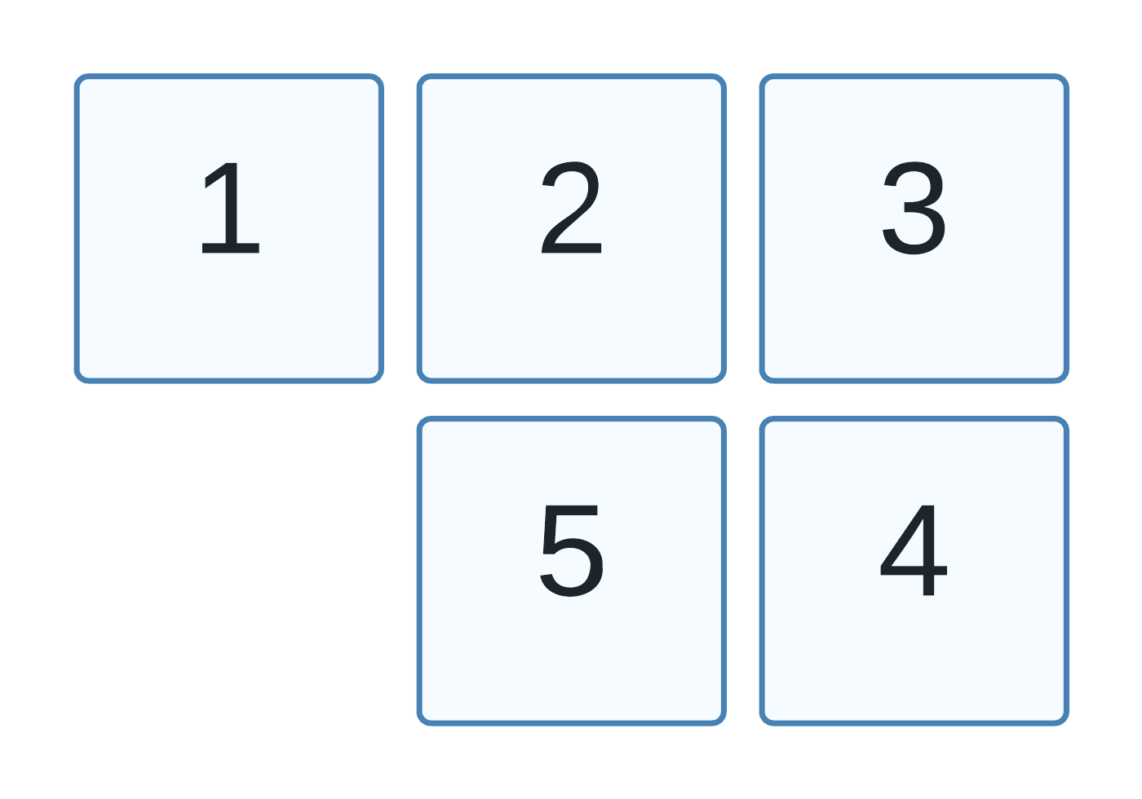

Q17. Write a program in python to do image segmentation using region growing technique/method.

**Region growing** is a region-based sequential technique for image segmentation by assembling pixels into larger regions based on **predefined seed** pixels, **growing criteria,** and **stop conditions**.

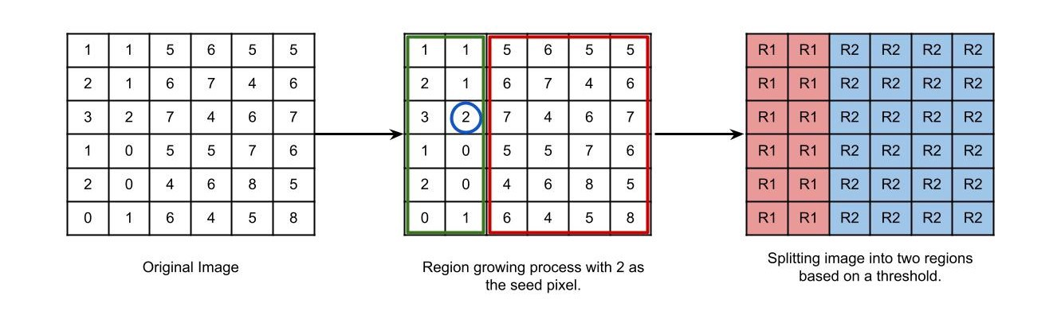In Region growing method, we start with some pixel as the **seed pixel** and then we check the adjacent pixels. If the adjacent pixels abide by the predefined rules, then that pixel is added to the region of the seed pixel and the following process continues till there is no similarity left. This method follows the bottom-up approach. In region growing, the preferred rule can be set as a threshold value. For example: let us consider a seed pixel of 2 in the given image and a threshold value is set as 3, if a pixel has a value greater than 3 then it will be considered inside the seed pixel region. Otherwise, it will be considered in another region. Hence 2 regions are formed in the following image based on a threshold value of 3. These 2 different regions that are formed are called as **segments** of an image.

**Figure 17.1** Illustrating Region Growing technique for image segmentation. *Source:* [*Image Segmentation: Part 2. Deep dive into various image… | by Mrinal Tyagi | Towards Data Science*](https://towardsdatascience.com/image-segmentation-part-2-8959b609d268)

So here as we can see clearly that choosing the initial seeds from the image is a very crucial part for doing image segmentation using region growing technique. Also, we have to properly choose here such a threshold value that ensure that the segments that are made will contain our desired pixels.

Here while designing our program, we have taken two approaches:

1) We call our first approach as **supervised approach**, as here in our program we have let user to select the initial seeds from the input image for doing segmentation. Here we have also let user to specify the desired threshold value also. Here the user can select multiple seeds from input image. How many seeds a user selects from a given input image, defines how many numbers of segments we get after the process of segmentation gets completed. In our program if a user selects multiple seeds form the input image, then the output image shows all these different segments with the help of different colours assigned to these different formed segments.

2) We call our first approach as **unsupervised approach**, as here in this approach, the program automatically selects the initial seeds from the input image for doing segmentation. Here we have still let the user to specify the threshold value to use for doing segmentation.

Now let us take a look at the programs for doing segmentation using region growing technique/ method and using both above listed approaches.

Following is the program for doing segmentation using region growing technique/ method (Supervised Approach):

**import** cv2  
**import** numpy **as** np  
**import** argparse  
*# This import statement is used to import the python packages or*  
*# modules that required by our program.*  
*# Here we are importing cv2 module which is used for image*  
*# reading and also for displaying images.*  
*# opencv read the images a numpy arrays.*  
*# Here we are also importing argparse*  
*# which is a command-line argument*  
*# parsing library which we are using here*  
*# to parse path to our image files here.*  
**class** Stack():  
 **def** __init__(self):  
 self.item = []  
 self.obj = []  
  
 **def** push(self, value):  
 self.item.append(value)  
  
 **def** pop(self):  
 **return** self.item.pop()  
  
 **def** size(self):  
 **return** len(self.item)  
  
 **def** isEmpty(self):  
 **return** self.size() == 0  
  
 **def** clear(self):  
 self.item = []  
  
  
**class** regionGrow():  
  
 **def** __init__(self, image_path, th_value):  
 self.readImage(image_path)  
 self.h, self.w, _ = self.im.shape  
 self.passedBy = np.zeros((self.h, self.w), np.double)  
 self.currentRegion = 0  
 self.iterations = 0  
 self.SEGS = np.zeros((self.h, self.w, 3), dtype=**'uint8'**)  
 self.stack = Stack()  
 self.thresh = float(th_value)  
  
 **def** readImage(self, img_path):  
 self.im = cv2.imread(img_path, 1)  
  
 **def** getNeighbour(self, x0, y0):  
 neighbour = []  
 **for** i **in** (-1, 0, 1):  
 **for** j **in** (-1, 0, 1):  
 **if** (i, j) == (0, 0):  
 **continue**  
 x = x0 + i  
 y = y0 + j  
 **if** self.limit(x, y):  
 neighbour.append((x, y))  
 **return** neighbour  
  
 **def** ApplyRegionGrow(self, seeds):  
 temp = []  
 **for** i **in** seeds:  
 temp.append(i)  
 temp.extend(self.getNeighbour(i[0], i[1]))  
 seeds = temp  
 **for** i **in** (seeds):  
 x0 = int(i[0])  
 y0 = int(i[1])  
  
 **if** self.passedBy[x0, y0] == 0 **and** (  
 int(self.im[x0, y0, 0]) * int(self.im[x0, y0, 1]) * int(self.im[x0, y0, 2]) > 0):  
 self.currentRegion += 1  
 self.passedBy[x0, y0] = self.currentRegion  
 self.stack.push((x0, y0))  
 **while** **not** self.stack.isEmpty():  
 x, y = self.stack.pop()  
 self.BFS(x, y)  
 self.iterations += 1  
 **if** (self.PassedAll()):  
 **break**  
 count = np.count_nonzero(self.passedBy == self.currentRegion)  
 **if** (count < 8 * 8):  
 self.passedBy[self.passedBy == self.currentRegion] = 0  
 x0 -= 1  
 y0 -= 1  
 self.currentRegion -= 1  
  
 **for** i **in** range(0, self.h):  
 **for** j **in** range(0, self.w):  
 val = self.passedBy[i][j]  
 **if** (val == 0):  
 self.SEGS[i][j] = 255, 255, 255  
 **else**:  
 self.SEGS[i][j] = val * 35, val * 90, val * 30  
 **if** (self.iterations > 200000):  
 print(**"Max Iterations"**)  
 print(**"Iterations : "** + str(self.iterations))  
 cv2.imshow(**"Segmented Image"**, self.SEGS)  
 cv2.waitKey(0)  
 cv2.destroyAllWindows()  
  
 **def** BFS(self, x0, y0):  
 regionNum = self.passedBy[x0, y0]  
 elems = []  
 elems.append((int(self.im[x0, y0, 0]) + int(self.im[x0, y0, 1]) + int(self.im[x0, y0, 2])) / 3)  
 var = self.thresh  
 neighbours = self.getNeighbour(x0, y0)  
  
 **for** x, y **in** neighbours:  
 **if** self.passedBy[x, y] == 0 **and** self.distance(x, y, x0, y0) < var:  
 **if** (self.PassedAll()):  
 **break**;  
 self.passedBy[x, y] = regionNum  
 self.stack.push((x, y))  
 elems.append((int(self.im[x, y, 0]) + int(self.im[x, y, 1]) + int(self.im[x, y, 2])) / 3)  
 var = np.var(elems)  
 var = max(var, self.thresh)  
  
 **def** PassedAll(self):  
  
 **return** self.iterations > 200000 **or** np.count_nonzero(self.passedBy > 0) == self.w * self.h  
  
 **def** limit(self, x, y):  
 **return** 0 <= x < self.h **and** 0 <= y < self.w  
  
 **def** distance(self, x, y, x0, y0):  
 **return** ((int(self.im[x, y, 0]) - int(self.im[x0, y0, 0])) ** 2 + (  
 int(self.im[x, y, 1]) - int(self.im[x0, y0, 1])) ** 2 + (  
 int(self.im[x, y, 2]) - int(self.im[x0, y0, 2])) ** 2) ** 0.5  
  
  
**def** Check_Mouse_Clicks(event, x, y, flags, param):  
 **global** points  
 **if** event == cv2.EVENT_RBUTTONDOWN:  
 cv2.destroyAllWindows()  
  
 **if** event == cv2.EVENT_LBUTTONDOWN:  
 seeds.append([y, x])  
  
  
ap = argparse.ArgumentParser()  
ap.add_argument(**"-i"**, **"--INPUTIMAGE"**, required=**True**, help=**"path to input image file to be read"**)  
ap.add_argument(**"-th"**, **"--THRESHOLDVALUE"**, required=**False**, default=10, help=**"enter the threshold value"**)  
args = vars(ap.parse_args())  
seeds = []  
supervisedSegmentationProgram = regionGrow(args[**"INPUTIMAGE"**], args[**"THRESHOLDVALUE"**])  
cv2.namedWindow(**"Non-Segmented input image (choose the initial seeds from the image by pressing left click button)"**)  
cv2.setMouseCallback(  
 **"Non-Segmented input image (choose the initial seeds from the image by pressing left click button)"**, Check_Mouse_Clicks)  
cv2.imshow(**"Non-Segmented input image (choose the initial seeds from the image by pressing left click button)"**,  
 cv2.imread(args[**"INPUTIMAGE"**], 1))  
cv2.waitKey(0)  
  
*# The below given statement call function ApplyRegionGrow(seeds)*  
*# and starts our program execution.*  
*# the function*  
*# Here the function ApplyRegionGrow(seeds) is the main function*  
*# of our program. this function takes seeds as its parameter.*  
*# These seeds are selected by the user.*  
supervisedSegmentationProgram.ApplyRegionGrow(seeds)

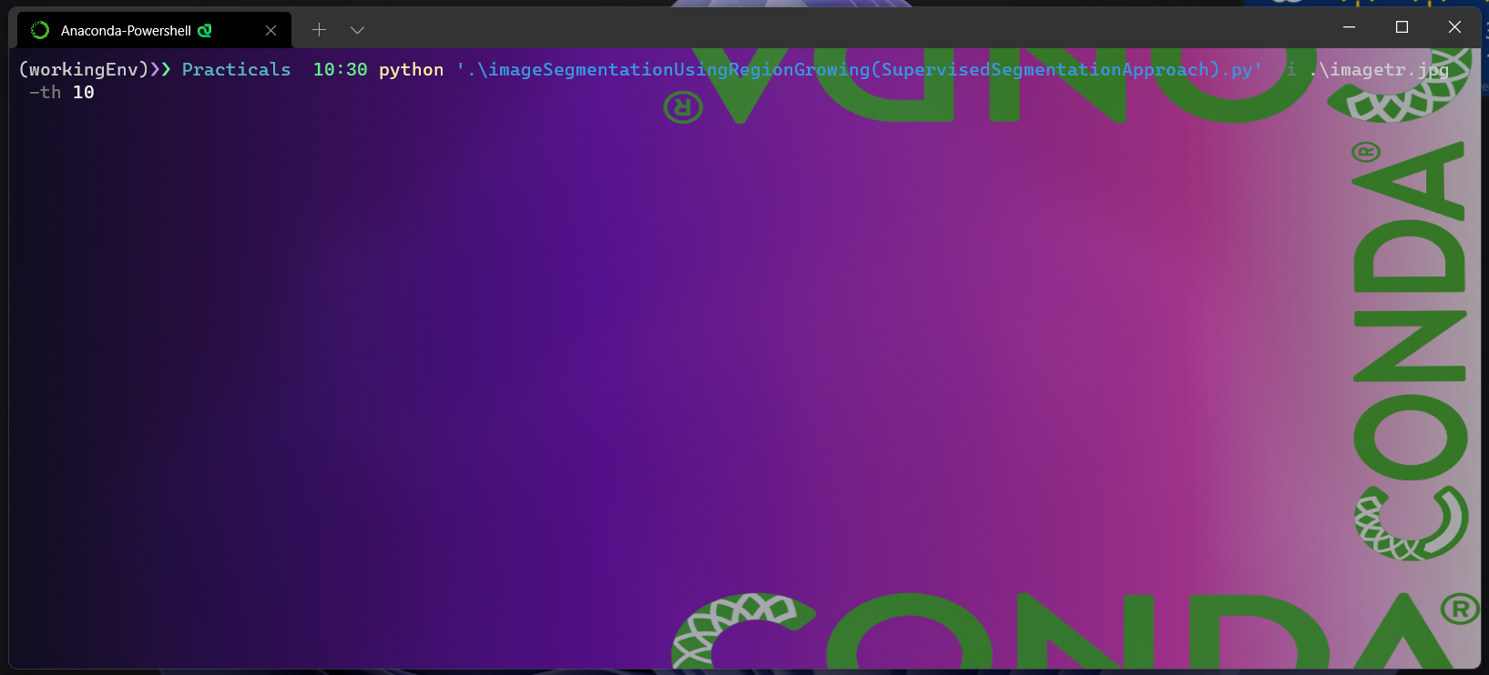Terminal Command (For running our program)

**Figure 17.1(a)** Terminal screen showing the command used for invoking the program (Supervised Approach).

Here in the above figure, you can see the command we have used to invoke our program execution. Here we are providing our program with two arguments. First argument is image file name which specifies the input image of which we want to do segmentation. Here the image file name in our program is imagetr.jpg. second argument that we are providing to our program is the threshold value that is used to define rule for doing segmentation. Here we have provided threshold value of 10 to our program as an argument.

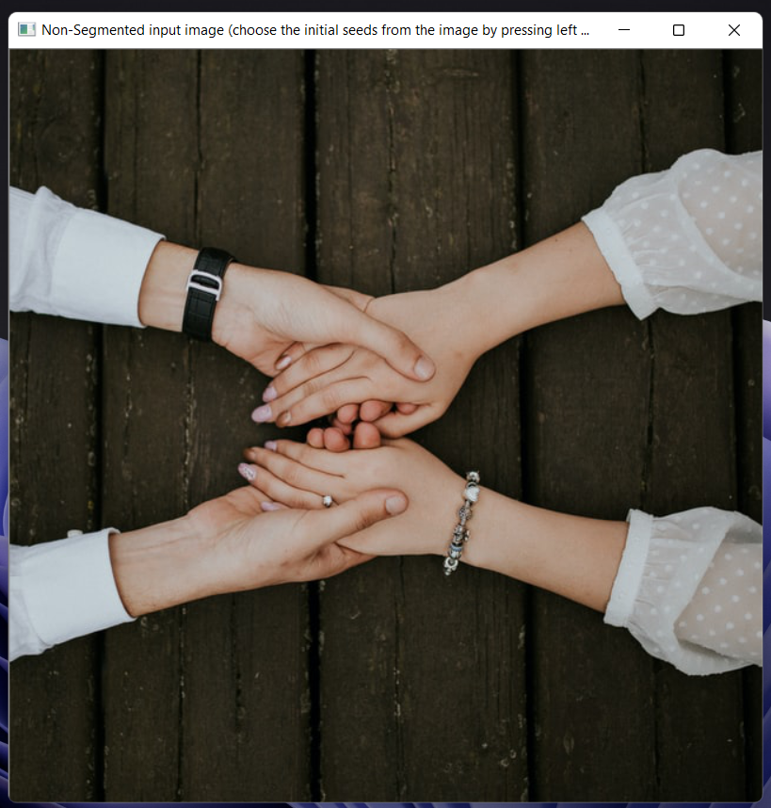 Output(Program in asking user to select the initial seeds):

**Figure 17.1(b)** Output of program for doing segmentation using region growing technique/ method (Supervised Approach) (Here program is asking, for selecting initial seeds/ pixels)

After executing our program, the program first asks the user to select the initial seeds from the image by pressing left mouse click on the area of image. After selecting all the seeds, the user must press right click to tell the program that I (user) have selected all the seeds so, start doing segmentation using the selected seeds.

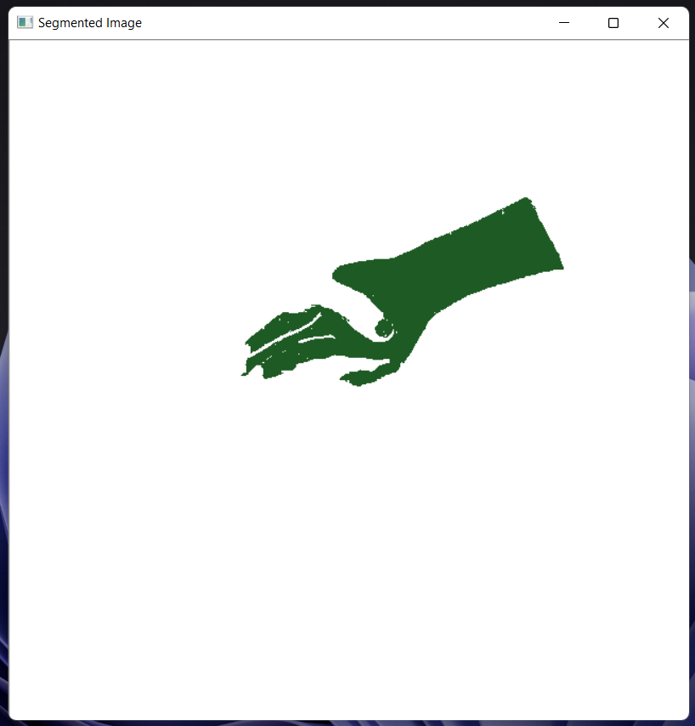Output (here user has selected one seed from the image):

**Figure 17.1(c)** Output of program for doing segmentation using region growing technique/ method (Supervised Approach) (Segmented image when we have selected only one seed and threshold value=10)

Here as we can see in the above image the hand represents that we have selected the initial seed/pixel from that are of the image. This green hand is going to be called as the segment of the image. As we have selected only one seed from the image so, the segments that we get is also equal to one.

Terminal output (when we have selected only one seeds):

**Figure 17.1(d)** Terminal Output of program for doing segmentation using region growing technique/ method (Supervised Approach) (when we have selected only one seed and threshold value=10)

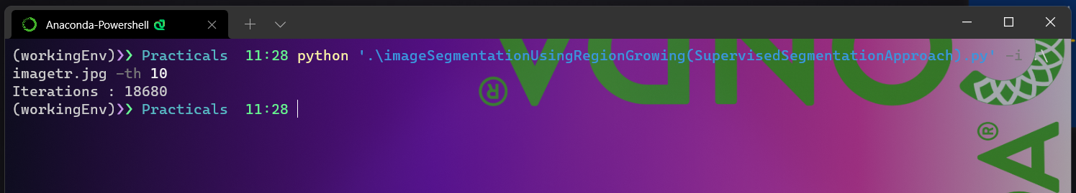

Here in the above terminal, we can see Iterations=18680, this signifies how many iterations does our program has taken to calculate segments from our selected seeds.

Output (here we has selected multiple seed from the image):

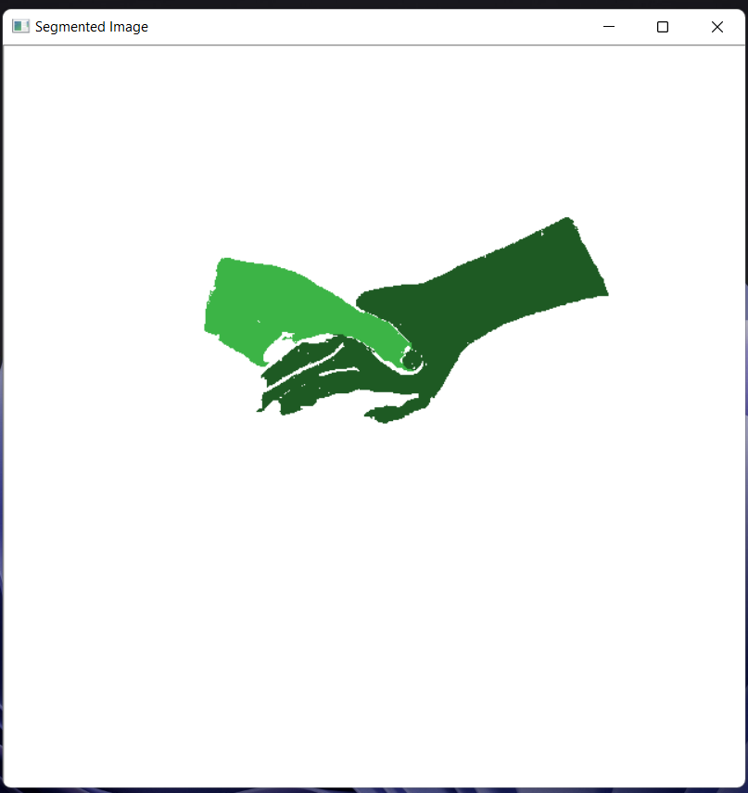

**Figure 17.1(e)** Output of program for doing segmentation using region growing technique/ method (Supervised Approach) (Segmented image when we have selected multiple seed which are 2 here and threshold value=10)

Here as we can see from the above image ,we are able to identify two hands, as one is in dark green, and the other is in light green. These two hands signify that we have selected two seeds here one from one hand and another seed from another hand. This one green hand and one dark green hand represent the two different segments calculated by selecting two different seeds.

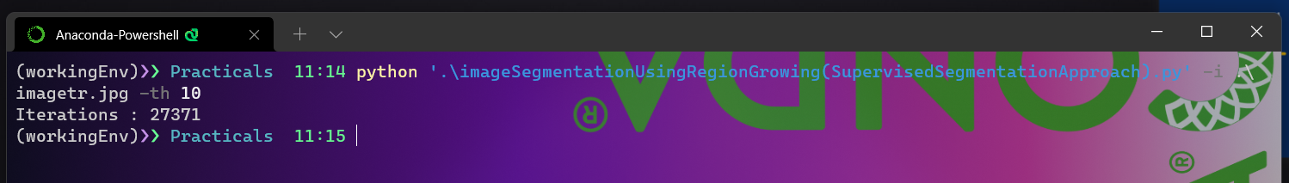Terminal output (when we have selected two seeds):

**Figure 17.1(f)** Terminal Output of program for doing segmentation using region growing technique/ method (Supervised Approach) (when we have selected multiple seed which are 2 here and threshold value=10)

Here in the above terminal, we can see Iterations=27371, this signifies how many iterations does our program has taken to calculate segments from our selected seeds.

Following is the program for doing segmentation using region growing technique/ method (Unsupervised Approach):

**import** cv2  
**import** numpy **as** np  
**import** argparse  
**import** random  
*# This import statement is used to import the python packages or*  
*# modules that required by our program.*  
*# Here we are importing cv2 module which is used for image*  
*# reading and also for displaying images.*  
*# opencv read the images a numpy arrays.*  
*# Here we are also importing argparse*  
*# which is a command-line argument*  
*# parsing library which we are using here*  
*# to parse path to our image files here.*  
  
  
*# class pour une pile*  
**class** Stack():  
 **def** __init__(self):  
 self.item = []  
 self.obj = []  
  
 **def** push(self, value):  
 self.item.append(value)  
  
 **def** pop(self):  
 **return** self.item.pop()  
  
 **def** size(self):  
 **return** len(self.item)  
  
 **def** isEmpty(self):  
 **return** self.size() == 0  
  
 **def** clear(self):  
 self.item = []  
  
  
**class** regionGrow():  
  
 **def** __init__(self, im_path, th):  
 self.readImage(im_path)  
 self.h, self.w, _ = self.im.shape  
 self.passedBy = np.zeros((self.h, self.w), np.double)  
 self.currentRegion = 0  
 self.iterations = 0  
 self.SEGS = np.zeros((self.h, self.w, 3), dtype=**'uint8'**)  
 self.stack = Stack()  
 self.thresh = float(th)  
  
 **def** readImage(self, img_path):  
 self.im = cv2.imread(img_path, 1)  
  
 **def** getNeighbour(self, x0, y0):  
 neighbour = []  
 **for** i **in** (-1, 0, 1):  
 **for** j **in** (-1, 0, 1):  
 **if** (i, j) == (0, 0):  
 **continue**  
 x = x0 + i  
 y = y0 + j  
 **if** self.limit(x, y):  
 neighbour.append((x, y))  
 **return** neighbour  
  
 **def** ApplyRegionGrow(self):  
 randomseeds = [[self.h / 2, self.w / 2],  
 [self.h / 3, self.w / 3], [2 * self.h / 3, self.w / 3], [self.h / 3 - 10, self.w / 3],  
 [self.h / 3, 2 * self.w / 3], [2 * self.h / 3, 2 * self.w / 3],  
 [self.h / 3 - 10, 2 * self.w / 3],  
 [self.h / 3, self.w - 10], [2 * self.h / 3, self.w - 10], [self.h / 3 - 10, self.w - 10]  
 ]  
 np.random.shuffle(randomseeds)  
 **for** x0 **in** range(self.h):  
 **for** y0 **in** range(self.w):  
  
 **if** self.passedBy[x0, y0] == 0 **and** (  
 int(self.im[x0, y0, 0]) * int(self.im[x0, y0, 1]) * int(self.im[x0, y0, 2]) > 0):  
 self.currentRegion += 1  
 self.passedBy[x0, y0] = self.currentRegion  
 self.stack.push((x0, y0))  
 self.prev_region_count = 0  
 **while** **not** self.stack.isEmpty():  
 x, y = self.stack.pop()  
 self.BFS(x, y)  
 self.iterations += 1  
 **if** (self.PassedAll()):  
 **break**  
 **if** (self.prev_region_count < 8 * 8):  
 self.passedBy[self.passedBy == self.currentRegion] = 0  
 x0 = random.randint(x0 - 4, x0 + 4)  
 y0 = random.randint(y0 - 4, y0 + 4)  
 x0 = max(0, x0)  
 y0 = max(0, y0)  
 x0 = min(x0, self.h - 1)  
 y0 = min(y0, self.w - 1)  
 self.currentRegion -= 1  
  
 **for** i **in** range(0, self.h):  
 **for** j **in** range(0, self.w):  
 val = self.passedBy[i][j]  
 **if** (val == 0):  
 self.SEGS[i][j] = 255, 255, 255  
 **else**:  
 self.SEGS[i][j] = val * 35, val * 90, val * 30  
 **if** (self.iterations > 200000):  
 print(**"Max Iterations"**)  
 print(**"Iterations : "** + str(self.iterations))  
 cv2.imshow(**""**, self.SEGS)  
 cv2.waitKey(0)  
 cv2.destroyAllWindows()  
  
 **def** BFS(self, x0, y0):  
 regionNum = self.passedBy[x0, y0]  
 elems = []  
 elems.append((int(self.im[x0, y0, 0]) + int(self.im[x0, y0, 1]) + int(self.im[x0, y0, 2])) / 3)  
 var = self.thresh  
 neighbours = self.getNeighbour(x0, y0)  
  
 **for** x, y **in** neighbours:  
 **if** self.passedBy[x, y] == 0 **and** self.distance(x, y, x0, y0) < var:  
 **if** (self.PassedAll()):  
 **break**;  
 self.passedBy[x, y] = regionNum  
 self.stack.push((x, y))  
 elems.append((int(self.im[x, y, 0]) + int(self.im[x, y, 1]) + int(self.im[x, y, 2])) / 3)  
 var = np.var(elems)  
 self.prev_region_count += 1  
 var = max(var, self.thresh)  
  
 **def** PassedAll(self):  
  
 **return** self.iterations > 200000 **or** np.count_nonzero(self.passedBy > 0) == self.w * self.h  
  
 **def** limit(self, x, y):  
 **return** 0 <= x < self.h **and** 0 <= y < self.w  
  
 **def** distance(self, x, y, x0, y0):  
 **return** ((int(self.im[x, y, 0]) - int(self.im[x0, y0, 0])) ** 2 + (  
 int(self.im[x, y, 1]) - int(self.im[x0, y0, 1])) ** 2 + (  
 int(self.im[x, y, 2]) - int(self.im[x0, y0, 2])) ** 2) ** 0.5  
  
  
ap = argparse.ArgumentParser()  
ap.add_argument(**"-i"**, **"--INPUTIMAGE"**, required=**True**, help=**"path to input image file to be read"**)  
ap.add_argument(**"-th"**, **"--THRESHOLDVALUE"**, required=**False**, default=10, help=**"enter the threshold value"**)  
args = vars(ap.parse_args())  
  
  
unsupervisedSegmentationProgram = regionGrow(args[**"INPUTIMAGE"**], args[**"THRESHOLDVALUE"**])  
unsupervisedSegmentationProgram.ApplyRegionGrow()

Terminal Command (For running our program)

**Figure 17.1(g)** Terminal screen showing the command used for invoking the program(unsupervised Approach).

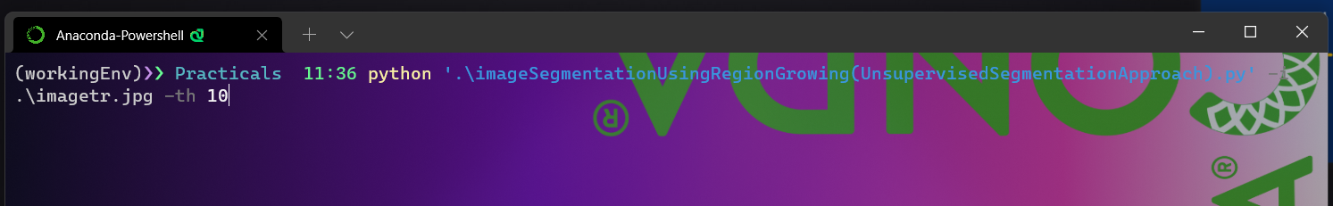

Here in the above figure, you can see the command we have used to invoke our program execution. Here we are providing our program with two arguments. First argument is image file name which specifies the input image of which we want to do segmentation. Here the image file name in our program is imagetr.jpg. second argument that we are providing to our program is the threshold value that is used to define rule for doing segmentation. Here we have provided threshold value of 10 to our program as an argument.

Output (here seeds are selected by our program automatically):

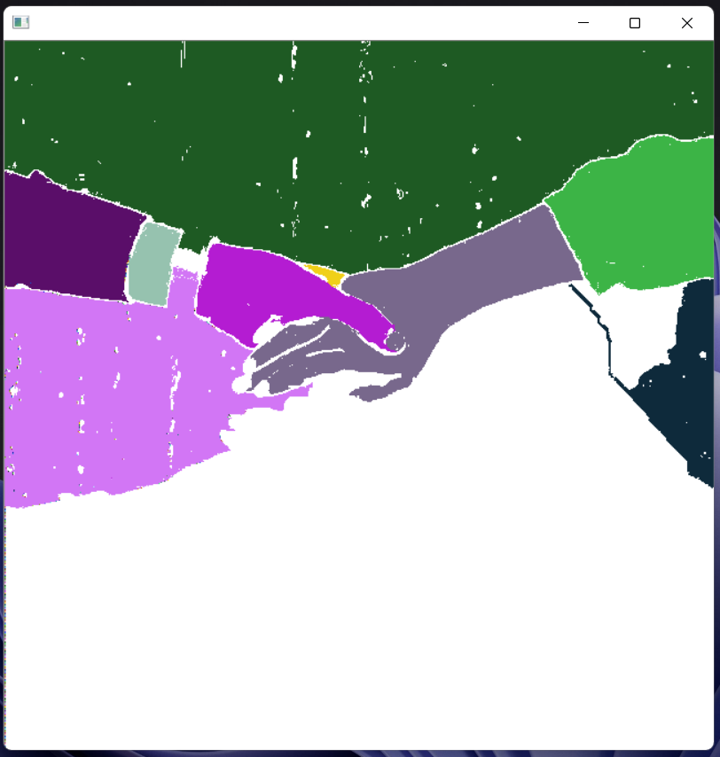

**Figure 17.1(h)** Output of program for doing segmentation using region growing technique/ method (Unsupervised Approach) (Segmented image when seeds are selected automatically by the program and threshold value=10)

As we can se here in the above figure we have multiple colours in our image. These different colours signify different number of segments that our program has calculated. Here these segments have been calculated from the initial seeds which a chosen by the program itself and not have been provided by any user.

Terminal output (unsupervised approach):

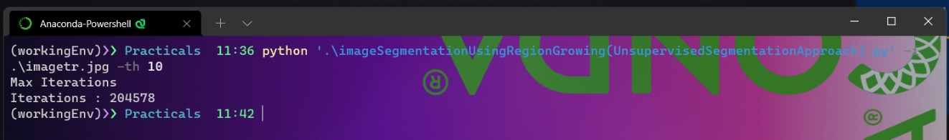

**Figure 17.1(i)** Terminal Output of program for doing segmentation using region growing technique/ method (Unsupervised Approach) (when seeds are selected automatically by the program and threshold value=10)

Here in the above terminal, we can see Iterations=204578, this signifies how many iterations does our program has taken to calculate segments from our selected seeds.